2009 AngelWeb training guide.

Entering Client Applications

AngelWeb is a website containing screens and reports used to enter and maintain Angel Tree information for clients of The Salvation Army.

The system is customizable by site and Corp/Unit. Depending on the site configuration, some screens and reports will contain fewer or more fields.

The URL address for this site is: _____________________________________________

1. The Login screen.

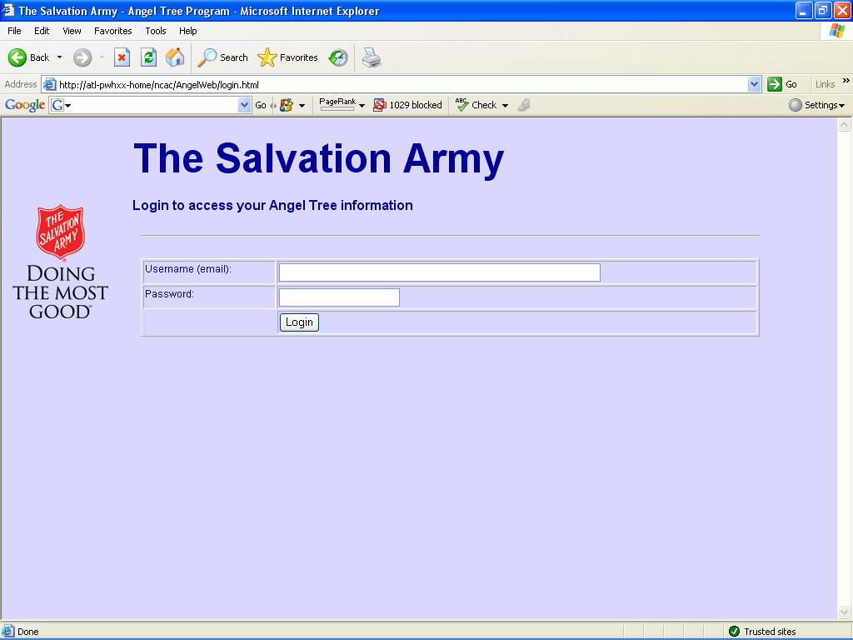

Enter your user name and password on the login screen to proceed to the main menu. Depending on your security level, you may have access to fewer or more options than shown on the screens in this guide.

The Main Menu.

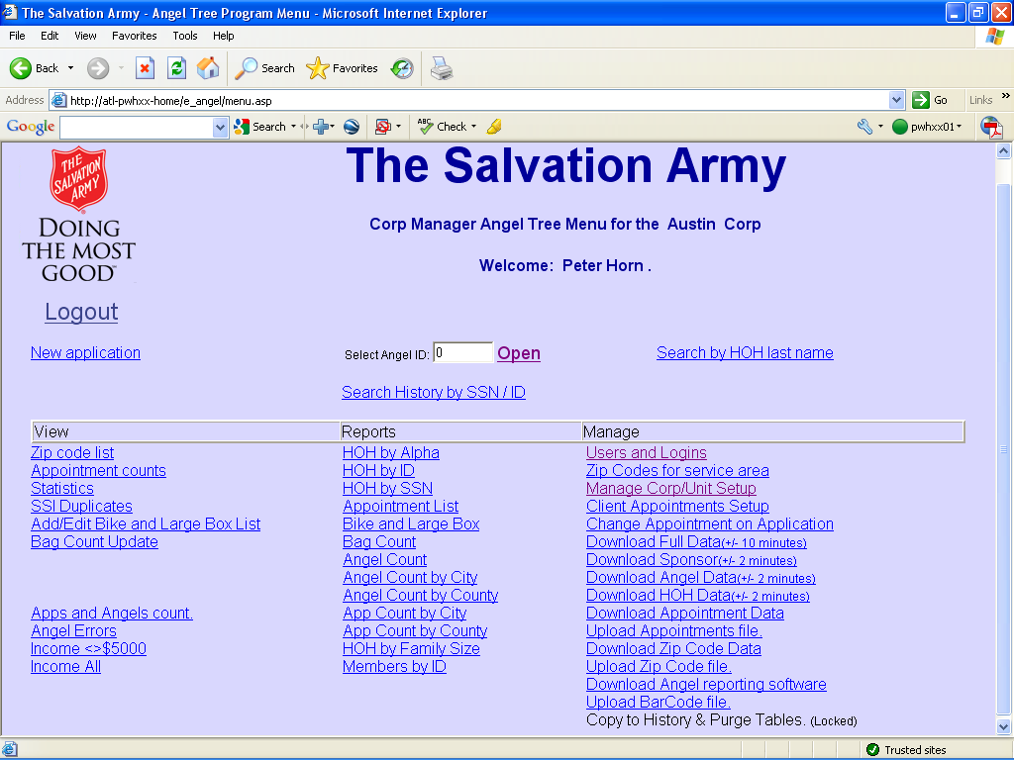

The Main Menu is the central navigation point for the system.

If you are entering Client information, your main focus will be the New application process. You may at times need to edit an existing application by entering the Client ID and clicking on OPEN or using the Search by HOH last name screen.

If your site is using History Lookup, and the client has been previously entered into the system, you can the option to Search History by SSN / ID.

Click on New Application.

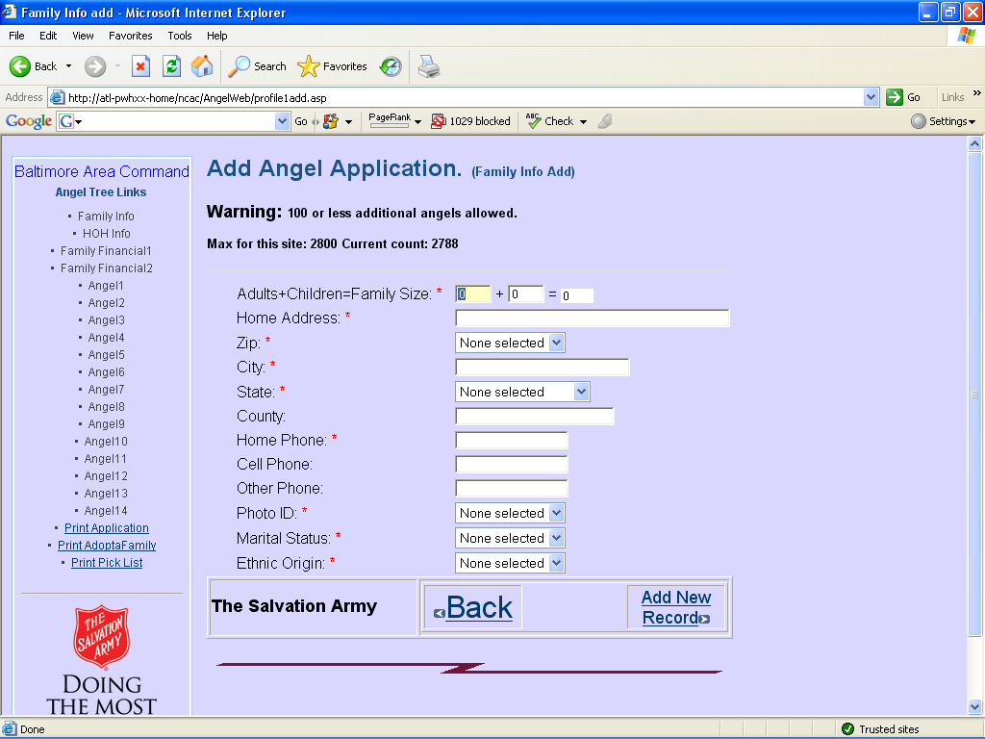

Note: Your site administrator may limit the number of Angels allowed. When your site is within 100 Angels of the limit, a warning message will be shown as in the above example.

Some fields in the system are required. You will be shown an error message when you try to save or update if the required field has not been entered.. You will know a field is required by the ‘*’ following the field label.

Screens are designed to take advantage of the tab field to move the cursor from field to field. For example, when you select a zip code and tab, it will automatically fill in the City, State, and County, and then take the cursor to the Home Phone field.

You can also navigate to a particular screen using the menu on the left side. If a particular screen has not been entered yet, you will not be able to navigate to it except via the next screen button.

Once you complete all of the required information, click on Add New Record. This will save the information in the database, assign a Client ID as well as a pickup appointment time, and take you to the next screen. Click on Add New Record.
HOH Info.
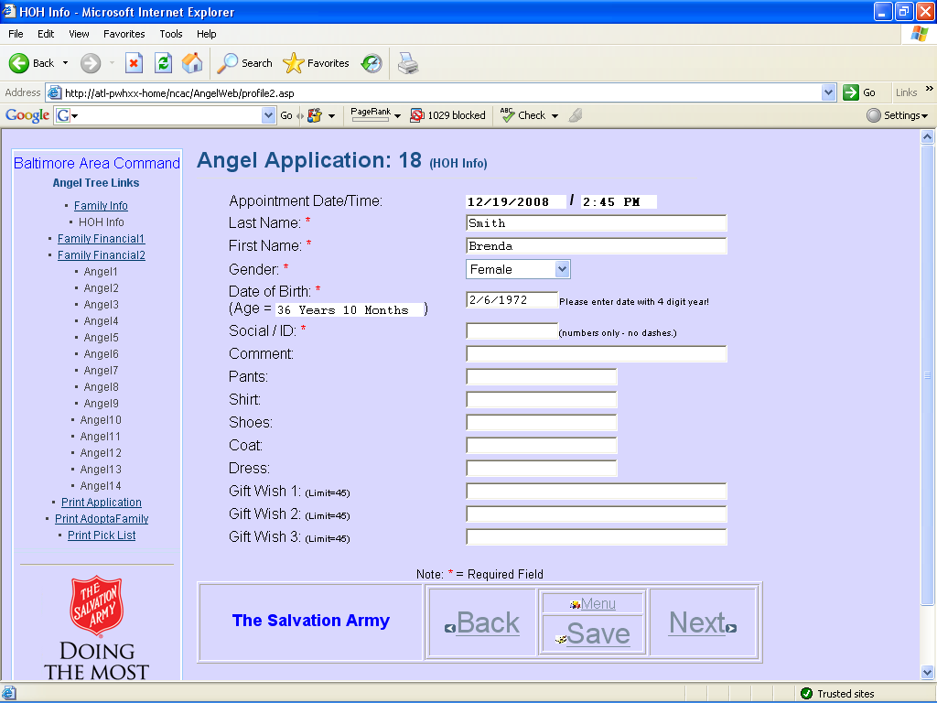

You can see that the Family Info link is now available because that screen has been completed. You can also see that the Client ID (18) and the appointment time are shown.

Fields that contain a dropdown can be quickly entered as you begin to learn what options are available. After entering Last and First name, you can tab to the Gender field, type an ‘f’ which causes the dropdown to select Female, and then tab to the Date of Birth field.

Dates in the system use the forward slash ‘/’ as a separator and require a 4 digit year. 1/2/2003 and 01/02/2003 will be accepted by the system. 1/2/03 will not be accepted.

The Social / ID field is required and is intended as a government issued Identification number such as the USA Social Security Card or Mexican matrícula consular ID card. Your site administrator can verify what is and is not acceptable.

Depending on your site configuration, the Head of House screen may or may not contain clothing and Gift Wish choices.

For all screens where the record has been created, you can click Save if you want to save and return to that screen, or click Next to save the current screen and move to the next screen.
Enter the required information and click Next.
Depending on how your site is configured, you may see:
- A single Financial screen (if using the Federal Poverty Guidelines)
- Separate Income and Expense screens (if this option is selected for your site).
- Some other family qualifier – such as a drop-down box on the HOH screen.

If your site is collecting financial information as a way of qualifying an applicant, you will be shown two screens to collect first Income and then Expense information.
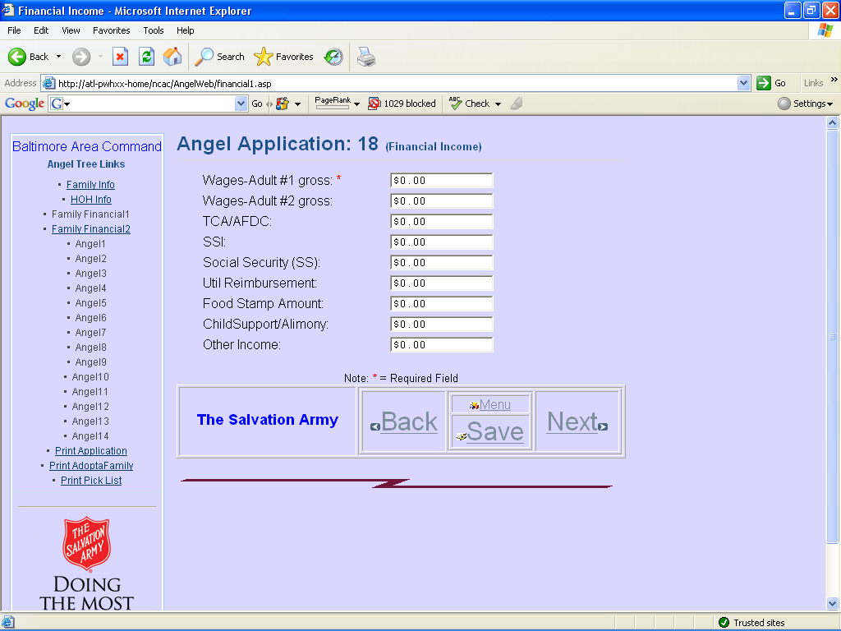

Click Next after entering this information.

Child #1 through Child #14 screens.

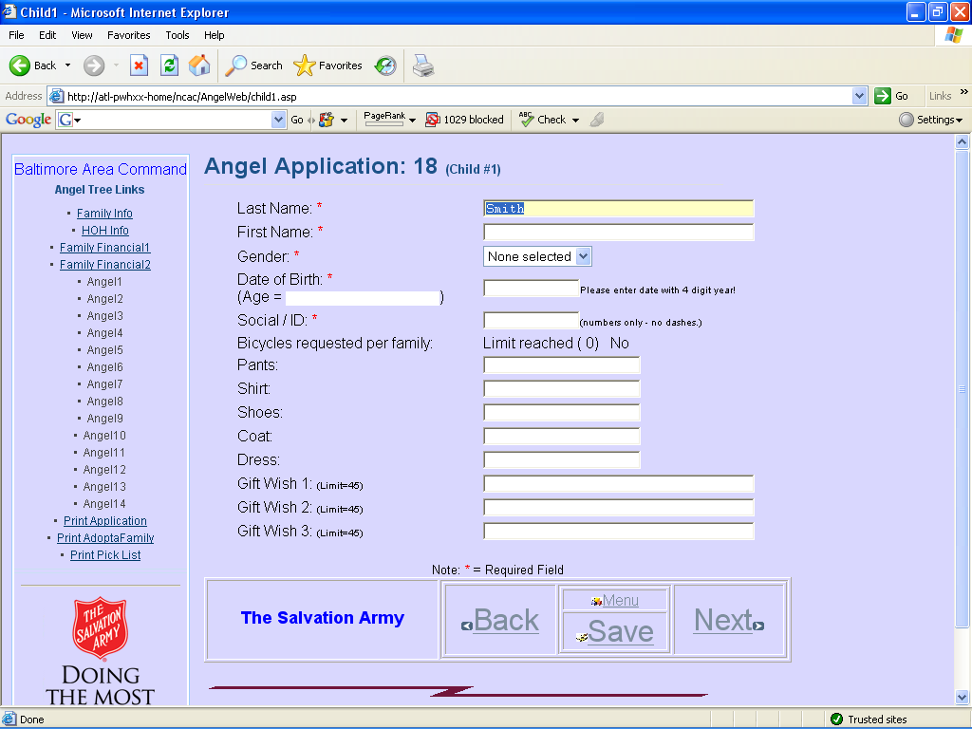

Your site may have the option turned on to autofill the Last Name from the HOH screen. If this needs to be updated for any of the child records, simply enter the new name.

The Date of Birth field will calculate the age of the child as of Christmas day. Typically, Angels are accepted if the child is under the age of 13 on Christmas day.

If your site is collecting Elder Angels, then this is typically for persons age 62 and older. Enter children and elder angels on screens 1 through 14.

Click Next or Save as needed.
Additional Children / Elder Angels

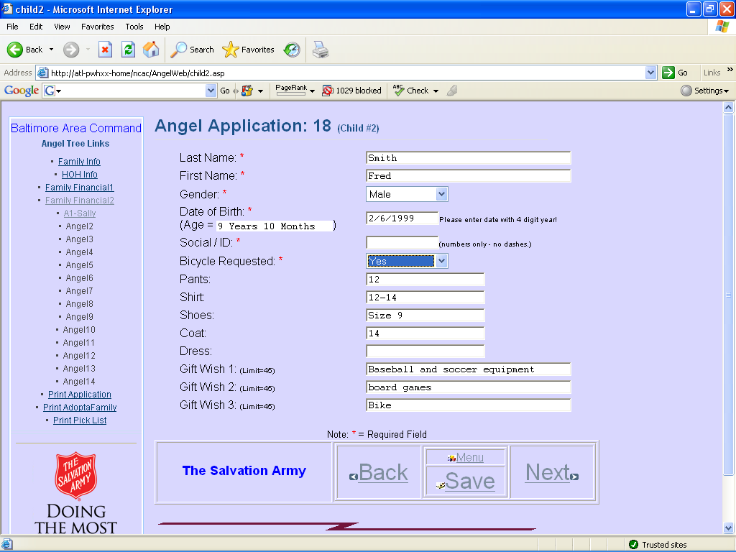

After entering the child information, you will notice that the link on the left side changes to show the Angel number as well as the child’s first name. You can click on this link if you need to go back and update information for this person.

Note the Bicycle Requested field. Select Yes if this child is requesting a bike or other riding toy. If your site limits the number of bikes per family, you may see a message that this family has exceeded the allowed number of requests. You will need to guild the client to respect this limit and select which children can request a bike.

Once you have completed the information for all of the people in this family, you should Save the last record and then click on Print Application.

Print Application

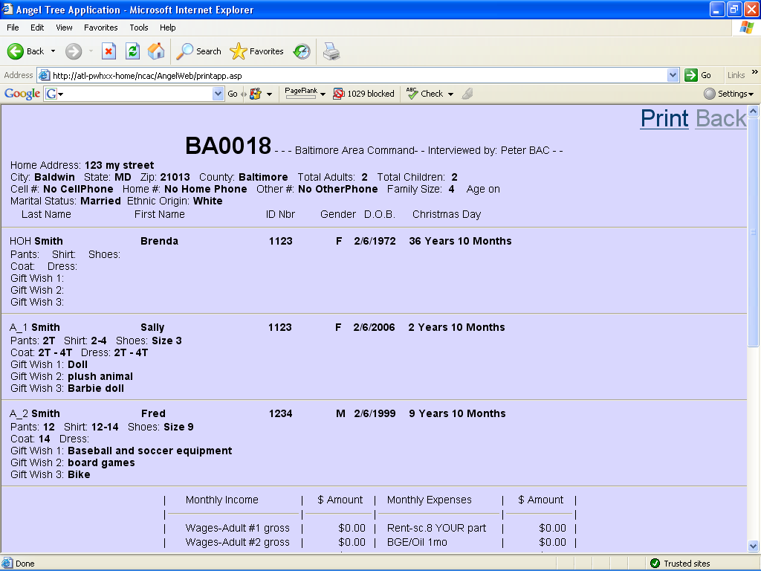

Print and review the application with the client to verify information. Have the client sign the application when satisfied that the information is correct.

Click on the BACK button (top right) to return to the application.

Click on Menu to return to the main menu.

Search History by SSN / ID.

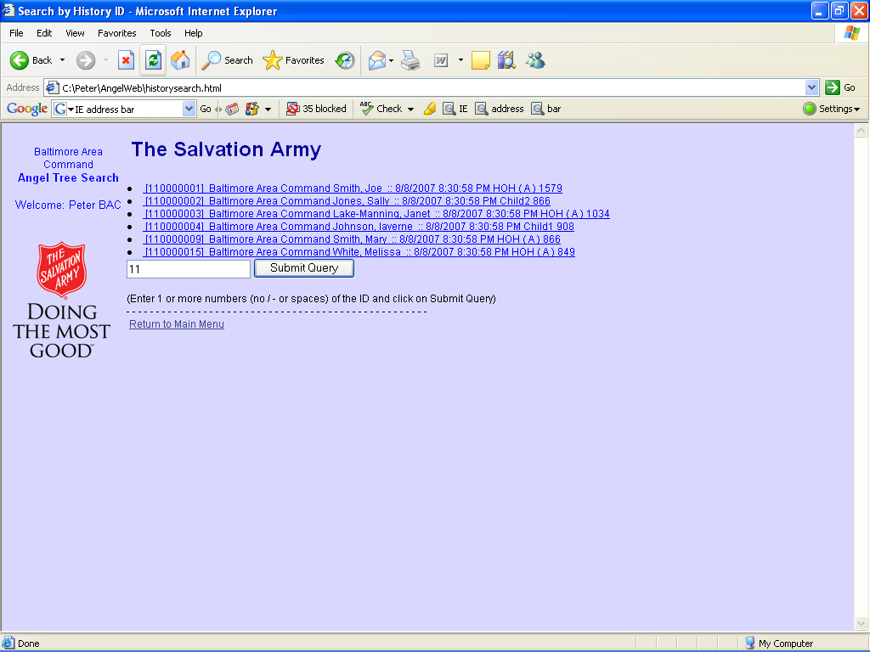

If your site is allowing History lookup, then you see this screen when clicking on the Search History by SSN / ID link from the menu. Enter the full SSN / ID of one of the children or the HOH from the previous year.

Select the record you want to import from History.
Copy from History screen.

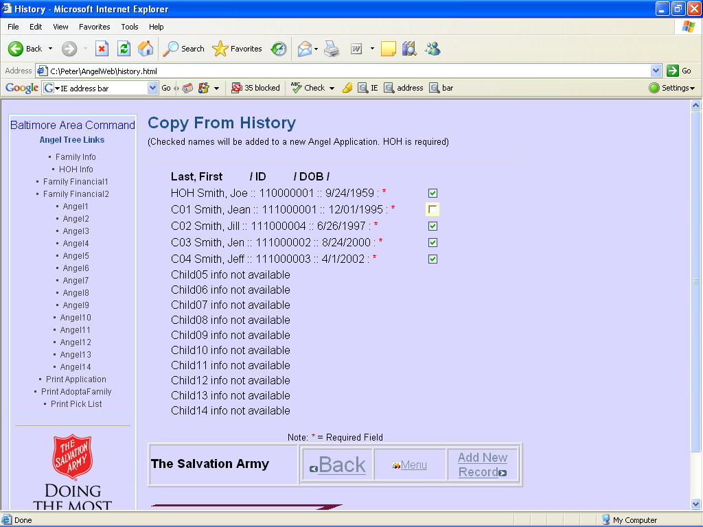

Now you can verify that each child should be included in this year’s application.

In the above example, Child 01 will be 13 this year and would not be eligible, so you would uncheck that child’s record.

Click on Add New Record.

Family Info.

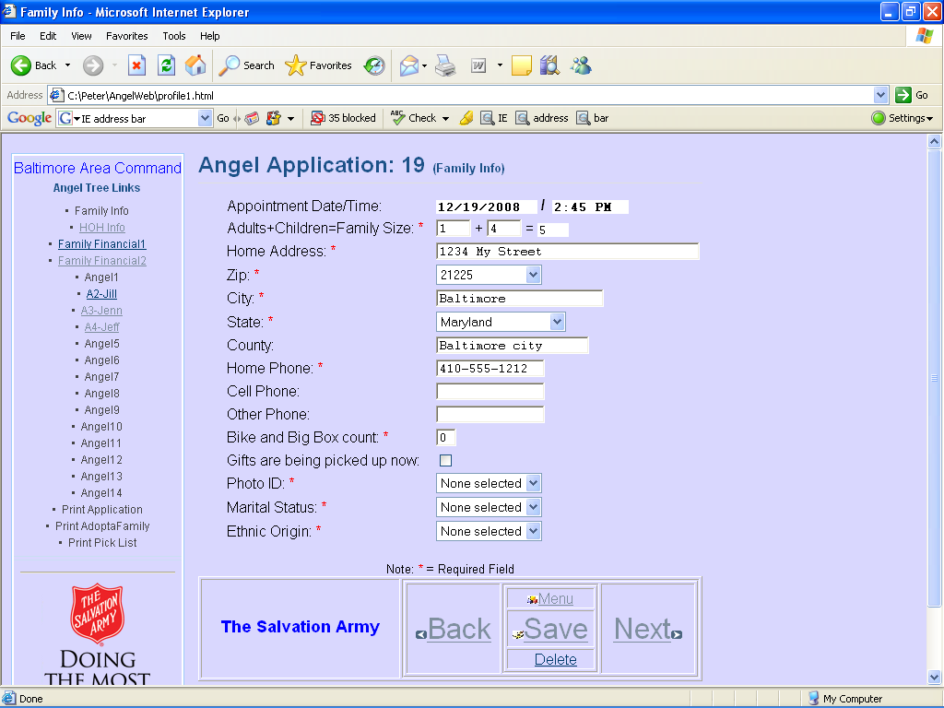

You need to go through and verify each record and answer the required information.

You will notice that since you did not import Child 01, that this link is not active. You can click on the active child links to update their records.

Reports and other views from the Main Menu.

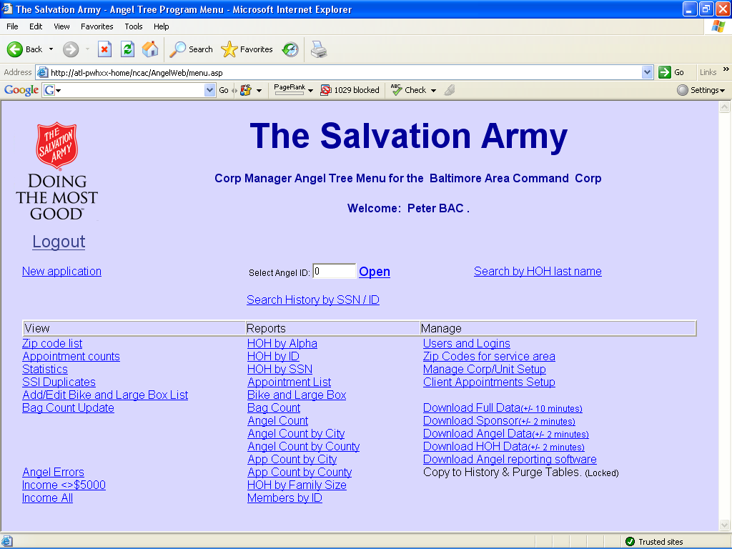

The remaining links and reports on the main menu open and display either a screen or a spreadsheet link. Click on the link to run the process or display the screen.
Spreadsheet reports:

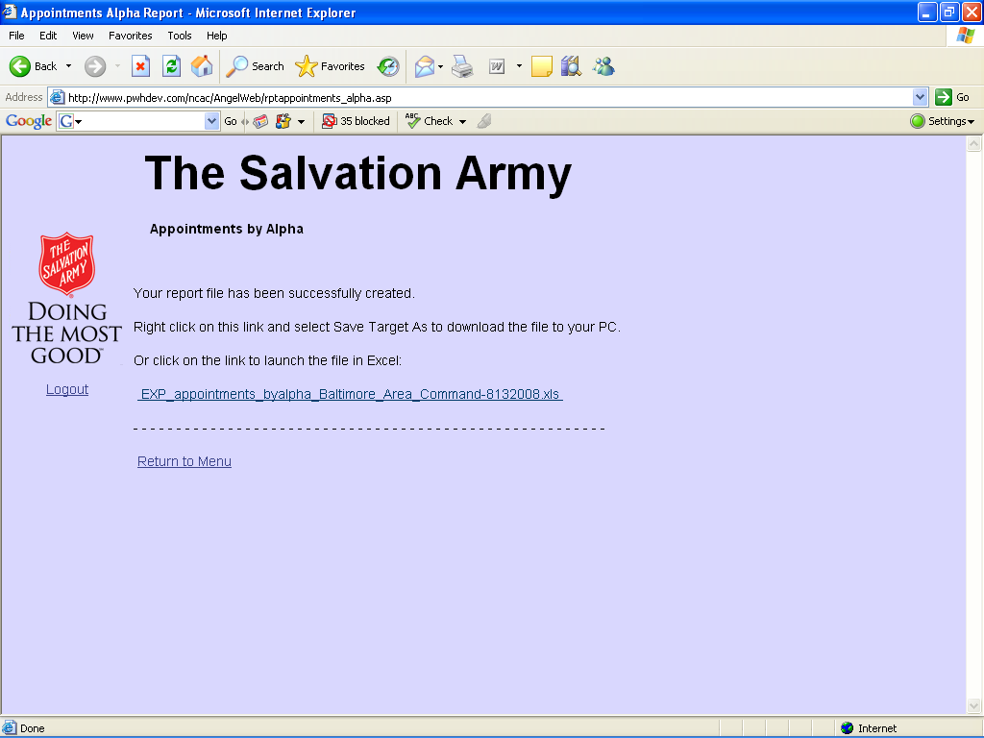

Once the report runs, you will see a screen like this.

You can either click on the link to open it or right-click, select save target as, and save the spreadsheet to your PC. Then open the spreadsheet with Excel.

For some reports, you may need to reduce the width of columns to allow it to print on a single page. You may also have better control when printing if you download and then print instead of just opening the spreadsheet from the link. This is because when you open the link, it opens Excel from inside IE – and you don’t have all of the same options available to you.

Error Messages:

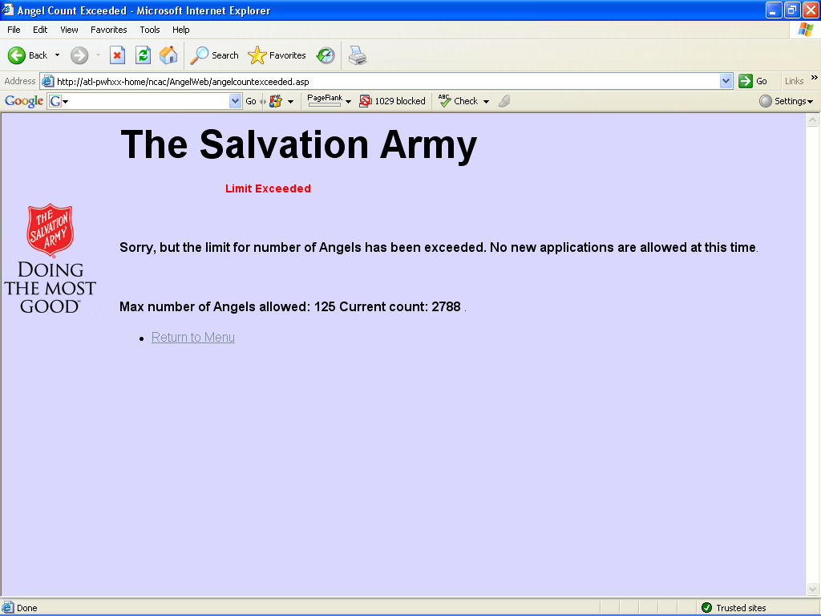

Your site administrator may limit the number of Angels allowed. Once this number is reached, you will see a screen like this.

Missing required info:

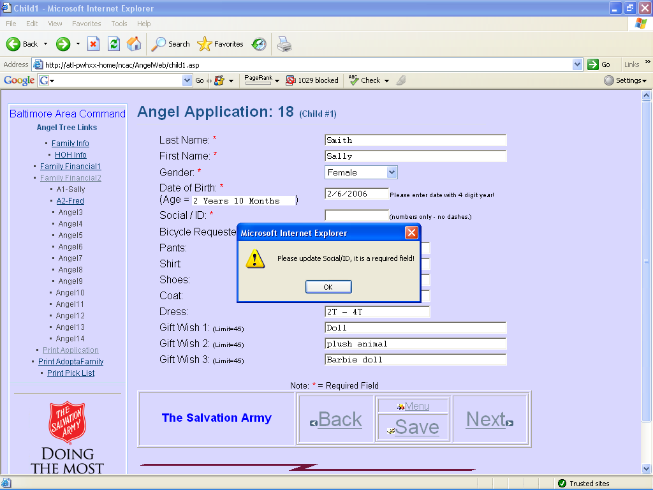

No Social / ID was entered. You can’t save the record before completing all required information.

If you try to navigate off of the screen, and the system knows that there is new data entered on the screen that has not been saved, you will see this message:

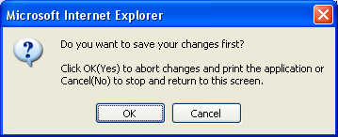

If you click OK, then the data will NOT BE SAVED. This may be an OK choice like if you accidentally entered something in a previously saved screen.

If you click Cancel then the navigation will not occur and you will be left on the screen so that you can complete and save the data before moving on.

Corps Manager Activities:

1. Managing your Corps Angel Setup.

Manage Corp/Unit Setup

From the main menu, click on: Manage Corp/Unit Setup

This will take you to the Corp/Unit Search page:
Enter the starting value to limit the search or click on Submit Query with no value entered to return all available Corps.
Note: For a Corps Manager, you will only see the Corps you manage.

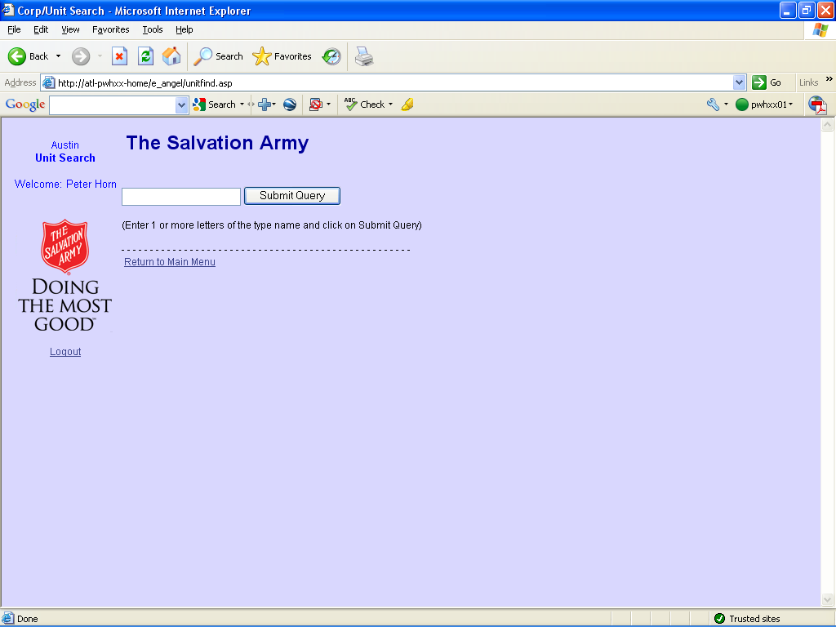

Click on the link to open the first management screen.

There are 5 sections in the Corp/Unit setup screens:

Section 1. Basic Corps Settings to manage how the site works
Corps Setup Info
Corps Setup Info 2

Section 2. Drop Down List Box questions and selection choices.
Validate DDLB1
Validate DDLB2
Validate DDLB3
Validate DDLB4
Validate DDLB5

Section 3. Short and Long answer questions.
angel_questions 1
angel_questions 2

Section 4. Application and Angel Tag informational messages.
angel_msg1
angel_msg2

Section 5. Financial Information Q & A.
angel_income
angel_expense

Corps Setup Info
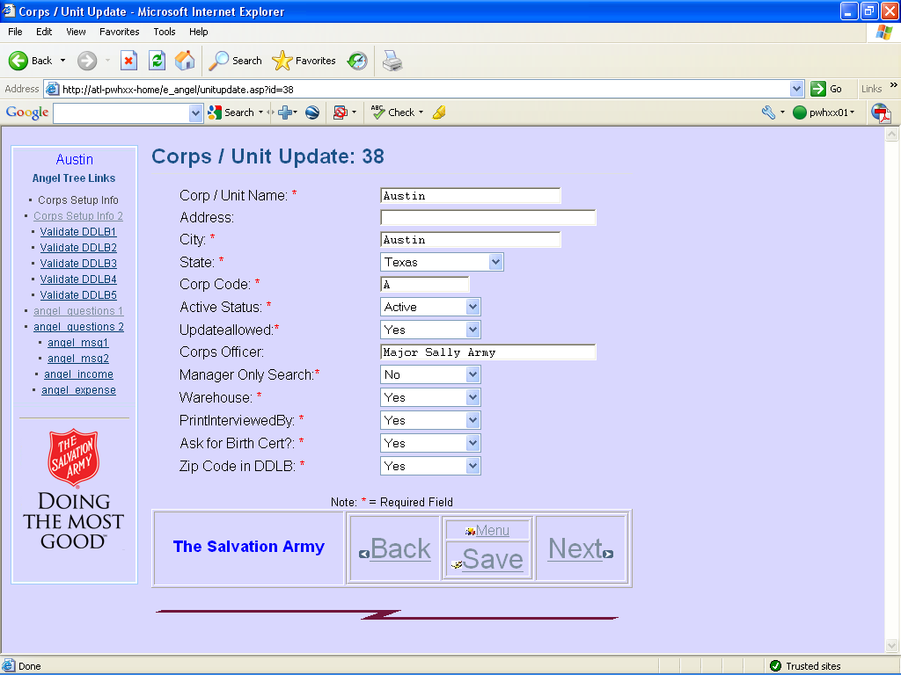

Corp Info (Corp Name and address, Corps Officer)
Corp Code is printed with the Angel ID to identify which Corps the angel belongs to.
The Angel ID is composed of 3 sections:
The Corp Code + The Application Number + The Member ID.
There can be up to 15 persons on one application.
The Head of Household (HOH) is assigned the letter Z.
Additional members or children make up the remaining 14 letters A thru N.
An Angel ID of A00078F indicates the Corps with the code of A, Client Application 00078 and Child or Member F or the 6th entry below the HOH.
Active Status (Yes/No) This Corps is active this year.

Update Allowed (Yes/No) You can disable further data entry with this option.
Manager Only Search (Yes/No) A User ID (type User) can’t search apps if No.
Warehouse (Yes/No) Inactive option.
Print Interviewed By (Yes/No) Print the Interviewer name on the Application.
Ask for Birth Cert (Yes/No) Was a Birth Cert verified for each person?
Zip Code in DDLB (Yes/No) If Yes, you select from a restricted list of zip codes. It will automatically fill in City / County / State when selected. If No, you free-type address information. This also helps restrict applications to a known list of zips.

Corps Setup Info 2
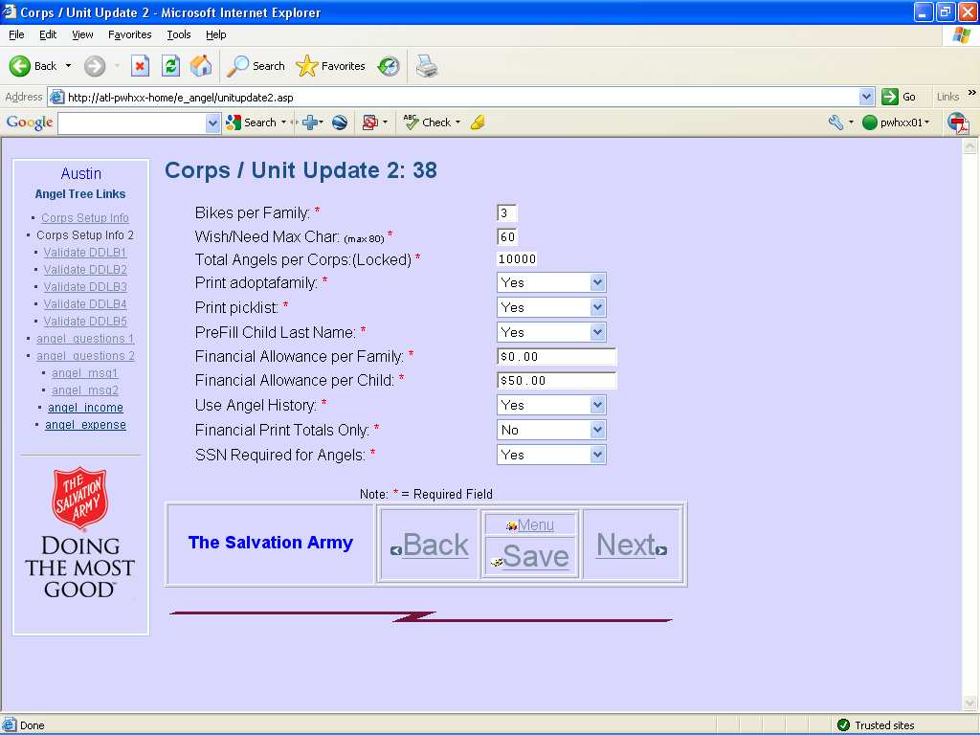
Bikes per Family Allow no more than this number of bikes per family.
Wish/Need Max Char Questions 6-9 allow up to 80 characters each. Reduce to this #.
Total Angels per Corps (Set by DHQ or site Manager) Limit the number of Apps that can be entered. Helps DHQ to monitor and prevent over extending resources.
Print adoptafamily (Yes/No) display this print option on the application screen.
Print picklist (Yes/No) display this print option on the application screen. Useful at pickup time when checking in clients at the door and printing the picklist back in the warehouse.
PreFill Child Last Name (Yes/No) enter the HOH last name for each child. Can be overridden when entering the child info.
Financial Allowance per Family Additional amt per family for qualifying financially.
Financial Allowance per Child Additional amt per child for qualifying financially.
Use Angel History (Yes/No) Allows search and import by ID from previous years apps.
Financial Print Totals Only Yes for totals only on the printed app. No for details.
SSN Required for Angels (Yes/No) Require an ID number for each child over 2.
Validation DDLB 1 – 5
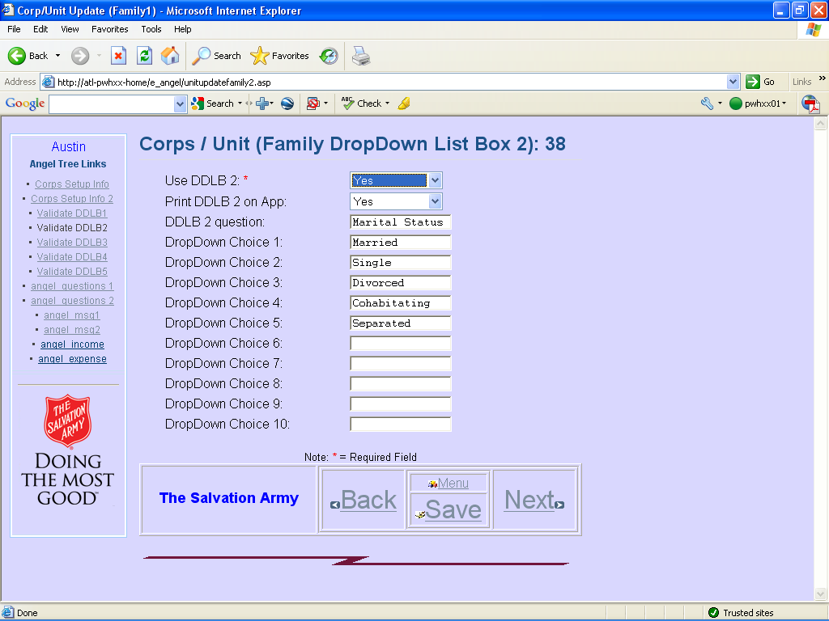
These 5 DDLB are shown on the HOH input screen.
Use DDLB (Yes/No) Enabled or not.
Print DDLB on App (Yes/No)
DDLB Question What do you want to ask about?
DropDown Choice 1-10 Up to 10 predefined answers can be shown for selection.
Angel Questions 1 5 Short Answer Questions
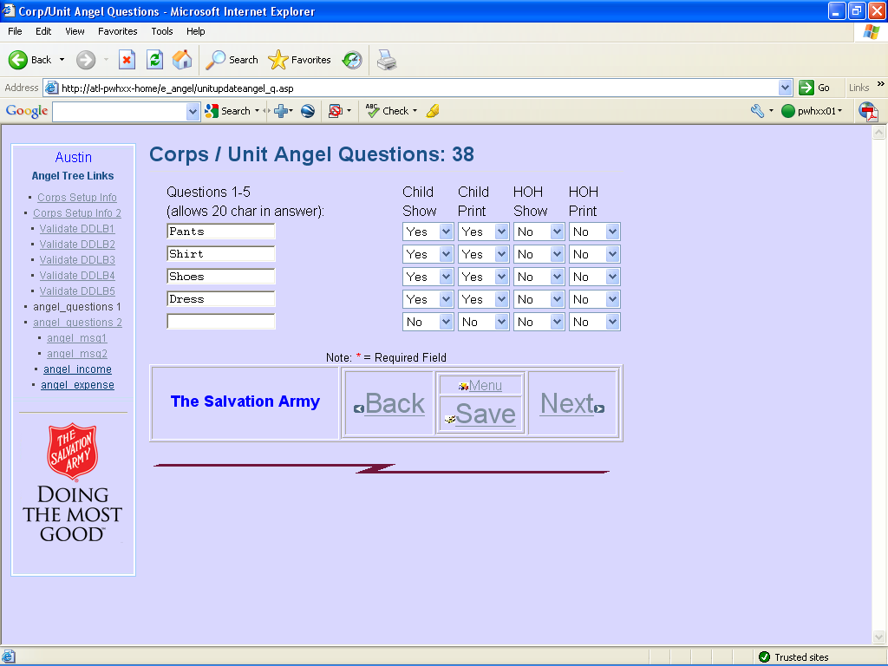

You can have up-to 5 fill-in-the-blank questions for each member.
Show (Yes/No) for children and HOH
Print on the Application (Yes/No) for children and HOH.
Ask any question and you have up to 20 characters to answer for each member.
Angel Questions 2 4 Long Answer questions
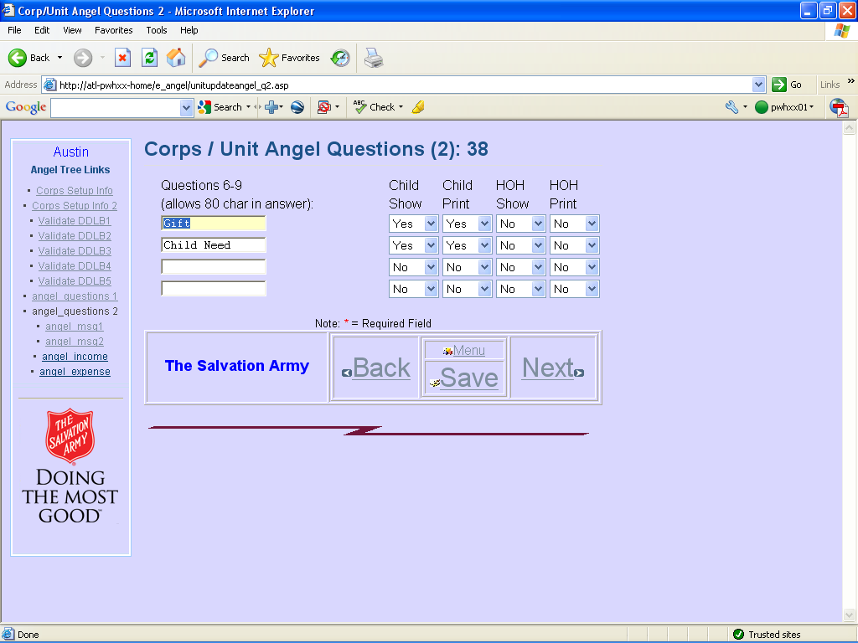
You can have up to 4 fill-in-the-blank long questions for each member.
Show (Yes/No) for children and HOH
Print on the Application (Yes/No) for children and HOH.
Ask any question and you have up to 80 characters to answer for each member. This can be restricted to fewer characters with the above Wish/Need Max Char option.
Angel Msg1 7 Informational Messages shown on the Printed Application
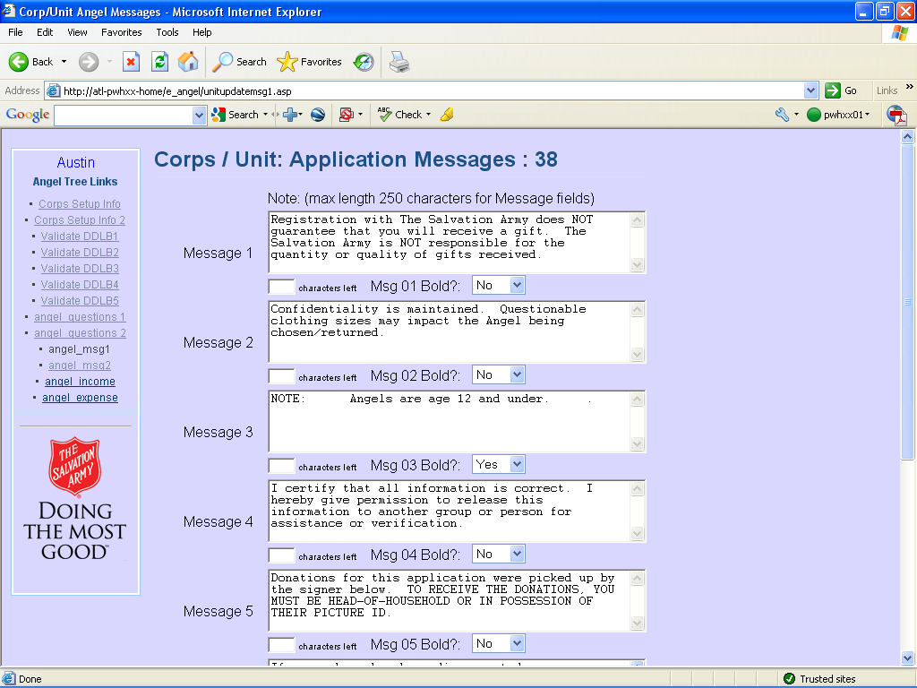

Each can be up to 250 characters long. Each can be printed in Bold or Normal.
The bottom of the printed application shows where the formatted messages are printed:
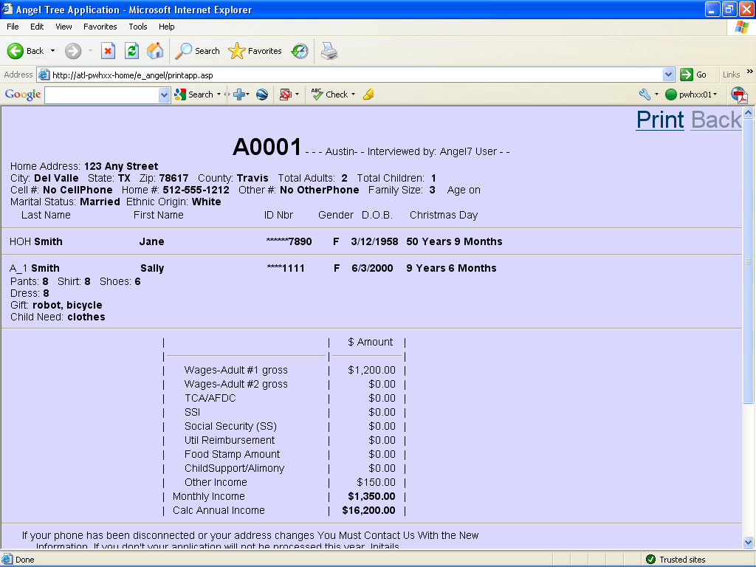
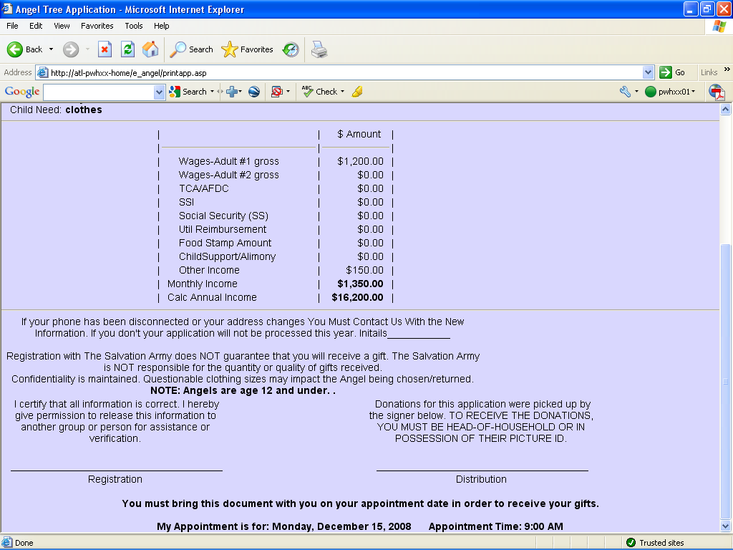

Angel Msg2 Informational Messages shown on the Printed Angel Tag.
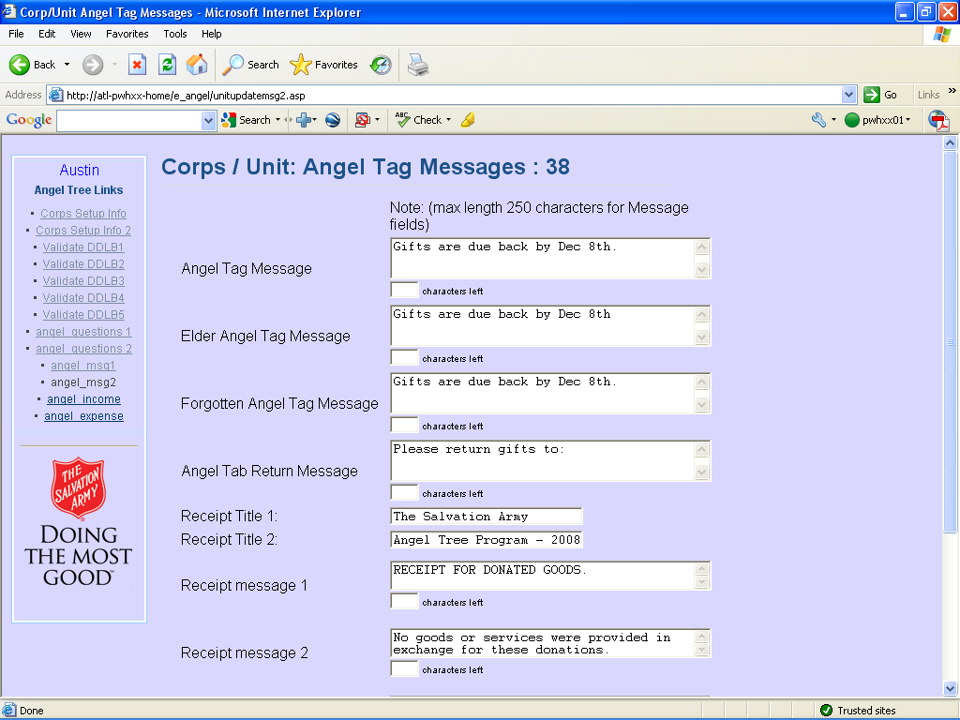
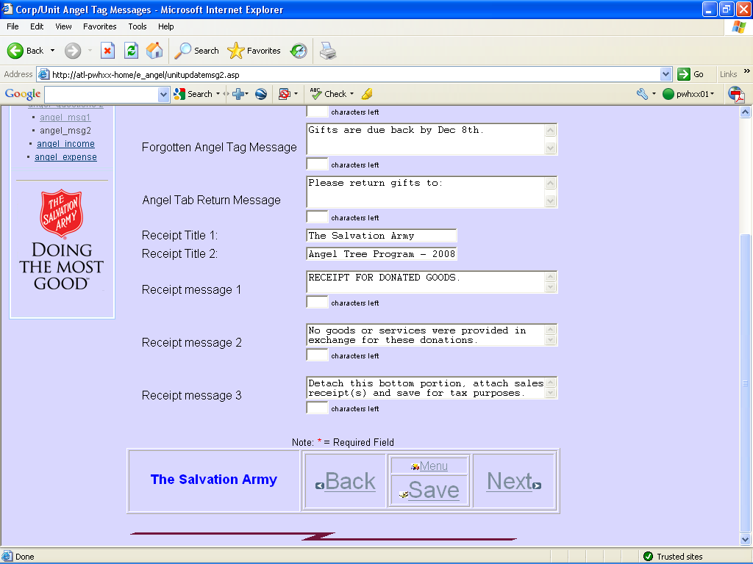

Angel Income Financial option selection and 9 Income Questions:
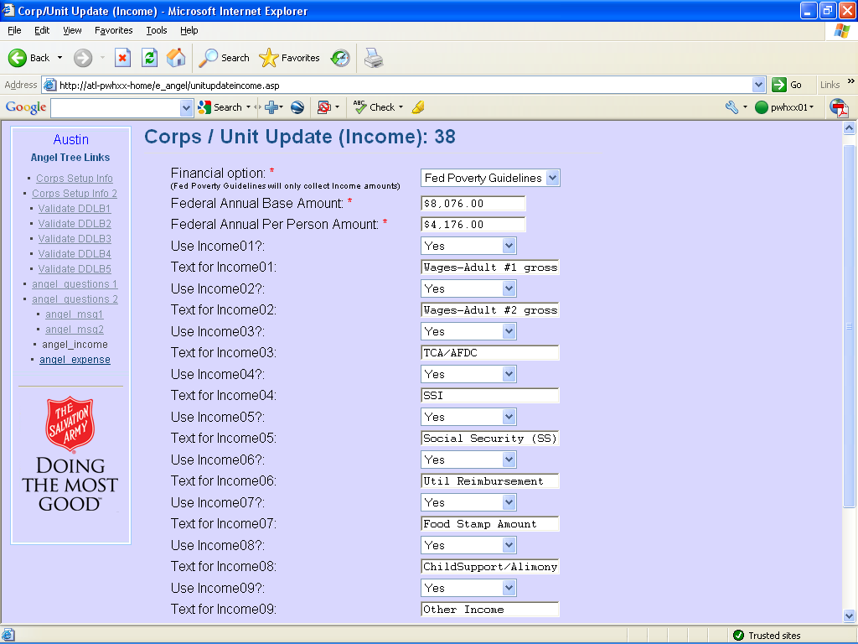

Financial option: Financial Qualification for each application.
Income + Expenses Display and collect Income and Expense information.
Fed Poverty Guidelines Use the Federal Poverty Guideline amounts
No Do not collect Financial Information.
Note: Fed Poverty Guidelines will only collect Income amounts.
Federal Annual Base Amount: Base Amount + Per Person Amount to determine allowed income per family.
Federal Annual Per Person Amount: Adults+Children=Family Size (from the Family Info screen) Not the number of children listed as Angels are 12 and under but Family Income qualification is based on the number of individuals in the household.
Use Income01 thru 09: (Yes/No) Include this question on the screen.
Text for Income01: Any question.

Angel Expense Financial Expense Questions:
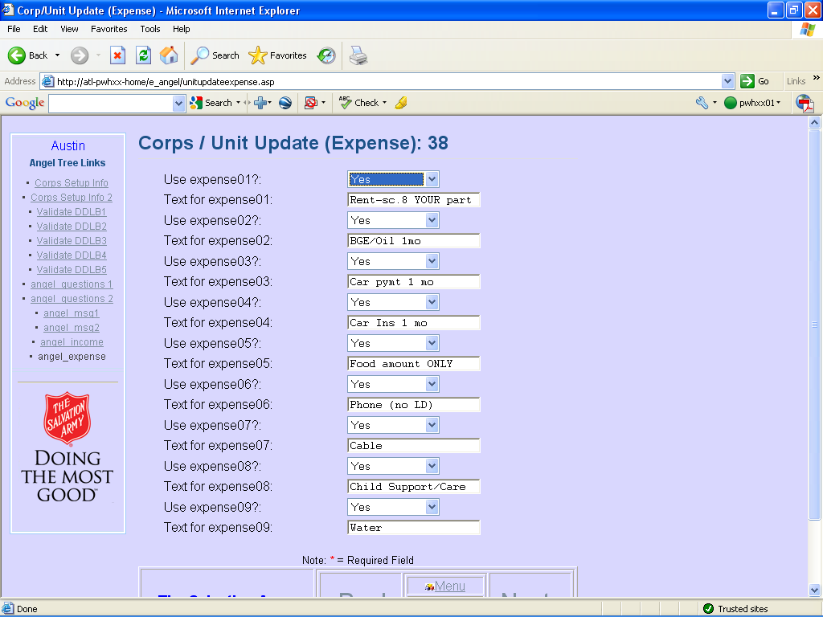
Use expense01 thru 09: (Yes/No) Include this question on the screen.
Text for expense01: Any question.

Users and Logins
Each Corps Manager can Create and manage Users and Corps Managers for their own Corps.
Select a User to work with or Click on Add New User to add.
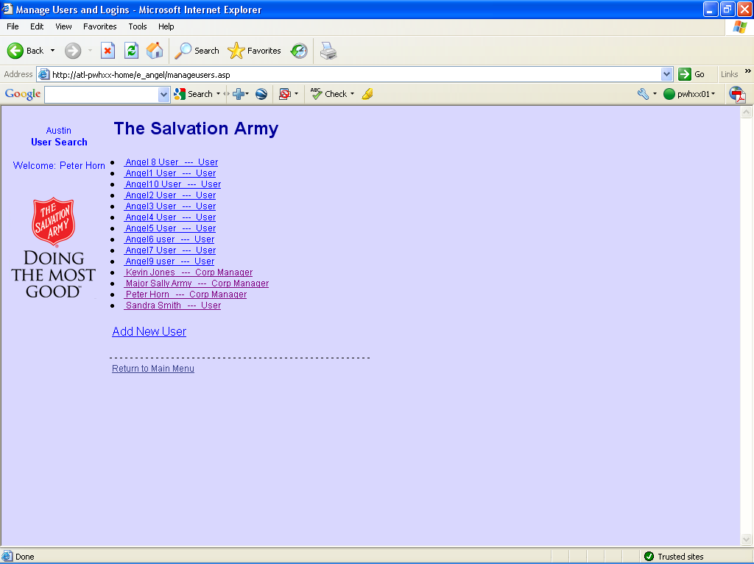

Add or Edit the user information.

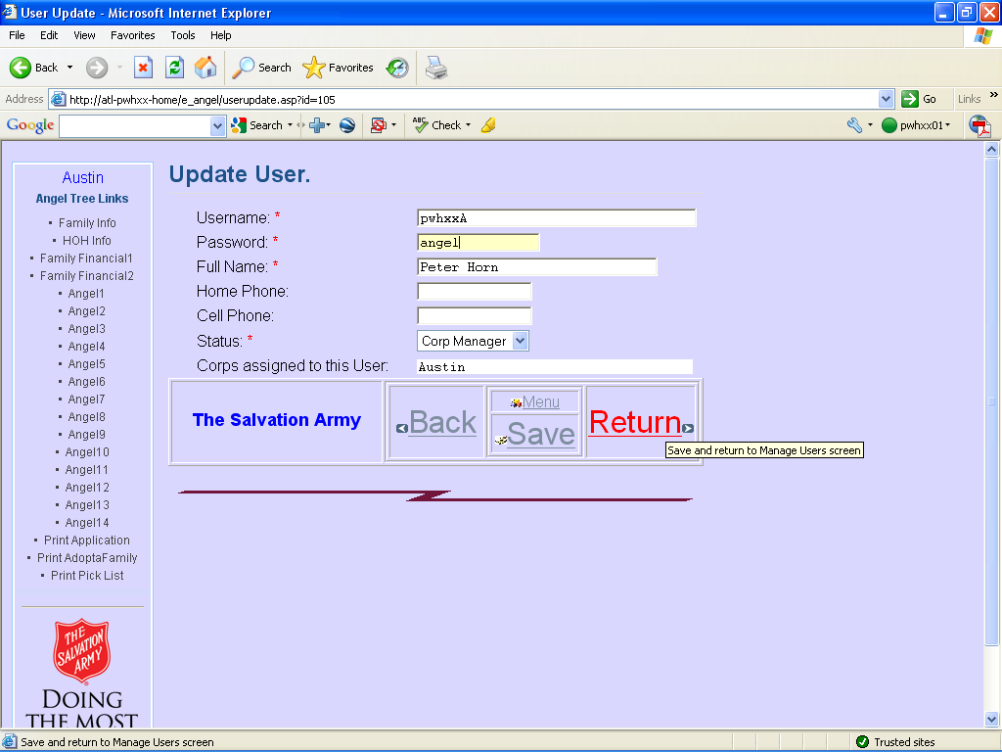

Status can be: User / Corp Manager or Inactive.

Users can manage their own password and user details.
Zip Codes Upload / Download and Edit zip codes.

Download Zip Code Data
From the Main Menu, Click on Download Zip Code Data
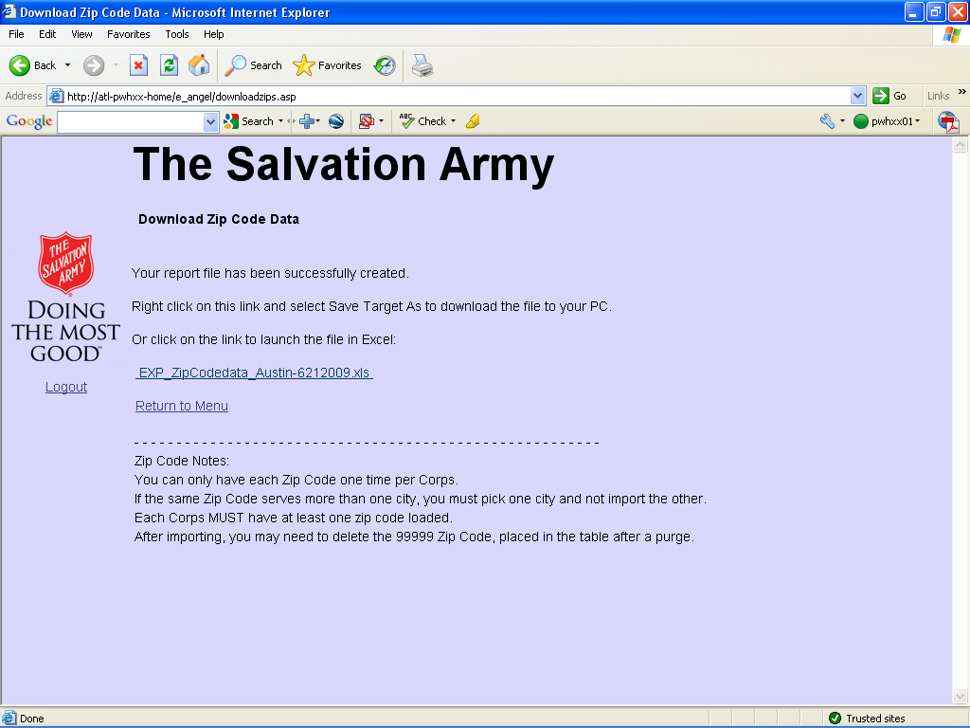
Right-Click on the spreadsheet link and save it to your hard drive.
Use this as a template to create a CSV file for importing zip codes.
Upload Zip Code file.
From the Main Menu, click on: Upload Zip Code file.
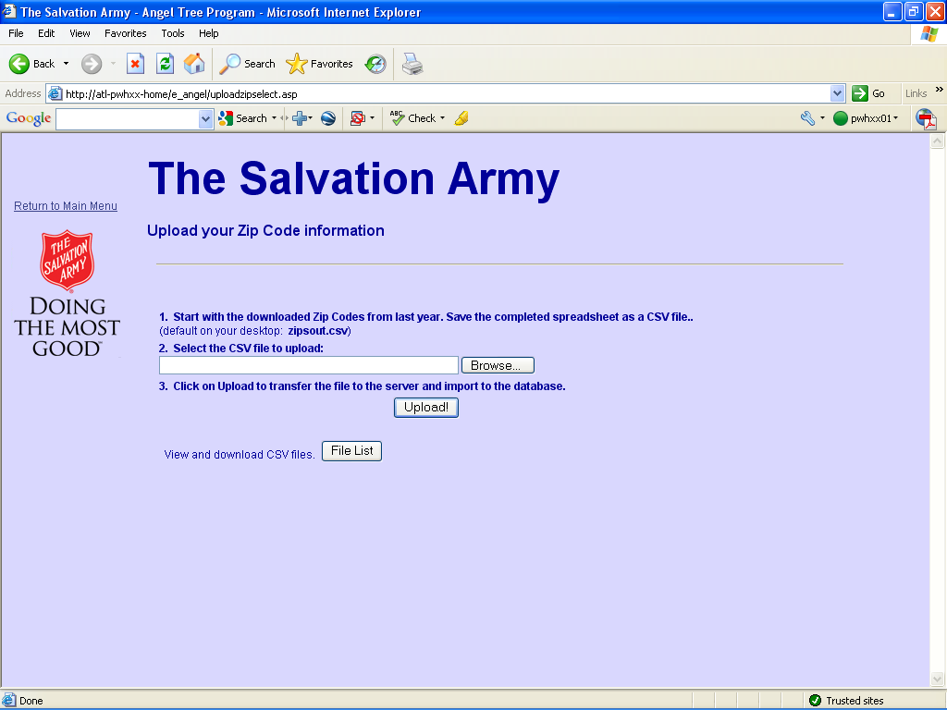
Locate and select the CSV file that contains the new zip codes and click upload

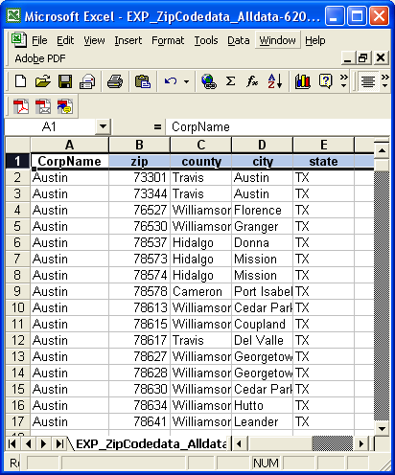

There are edits for each field in the CSV file and these will be reported on the next screen with the results:

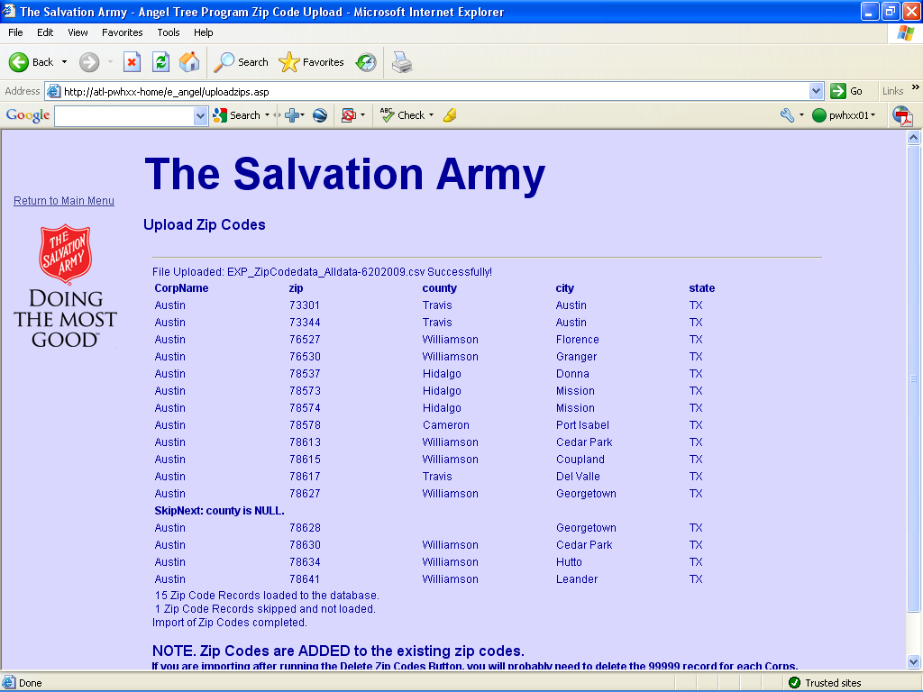

The above report shows:
15 Zip Code Records loaded to the database.
1 Zip Code Records skipped and not loaded.
Zip Codes for service area

From the Main Menu, you can also add and edit zip codes.
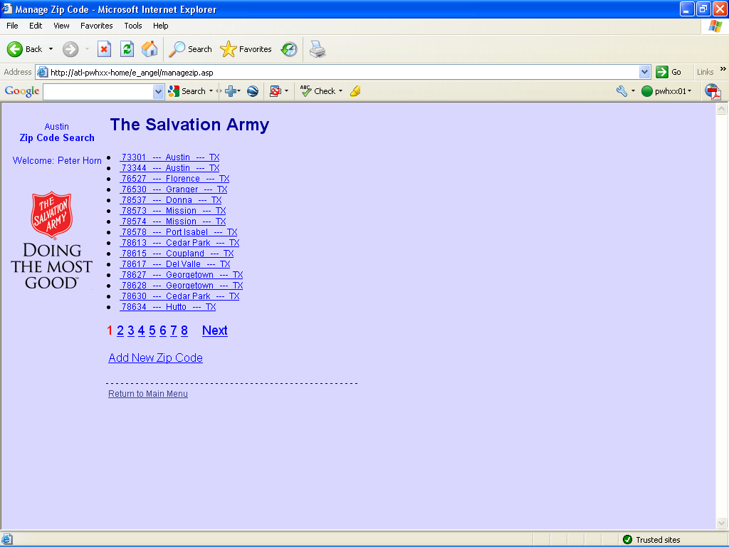
Select the zip code to work with or click on Add New Zip Code.

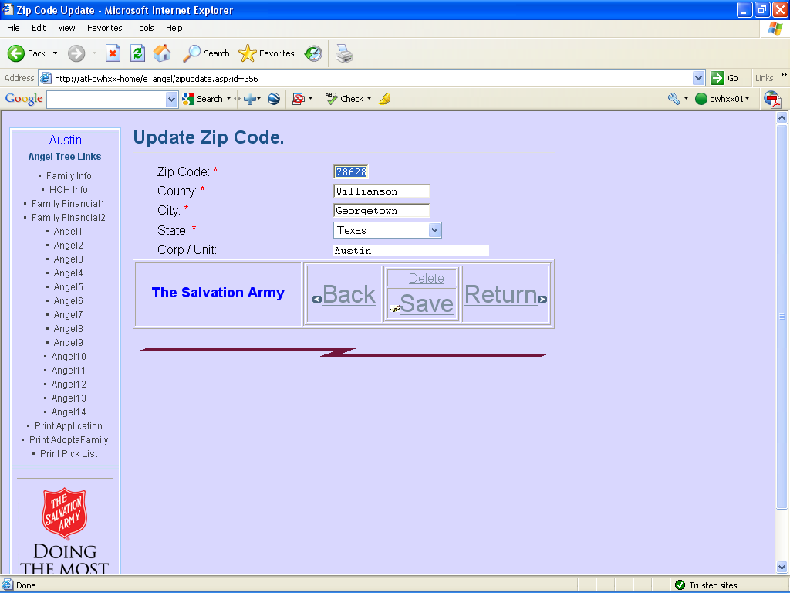

Client Appointments Upload / Download and Edit Client Appointment Times.
Download Appointment Data
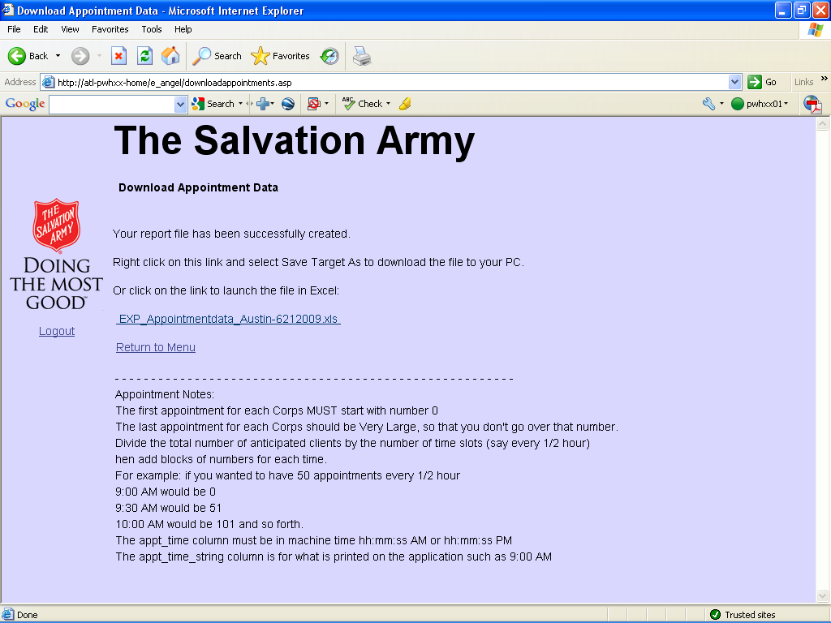
Right-Click on the spreadsheet link and save it to your hard drive.
Use this as a template to create a CSV file for importing Client Appointments.

Appointment Notes:
The first appointment for each Corps MUST start with number 0
The last appointment for each Corps should be Very Large, so that you don't go over that number.
Divide the total number of anticipated clients by the number of time slots (say every 1/2 hour)
Then add blocks of numbers for each time.
For example: if you wanted to have 50 appointments every 1/2 hour
9:00 AM would be 0
9:30 AM would be 51
10:00 AM would be 101 and so forth.
The appt_time column must be in machine time hh:mm:ss AM or hh:mm:ss PM
The appt_time_string column is for what is printed on the application such as 9:00 AM
Upload Appointments file.
From the Main Menu, click on: Upload Appointments file.
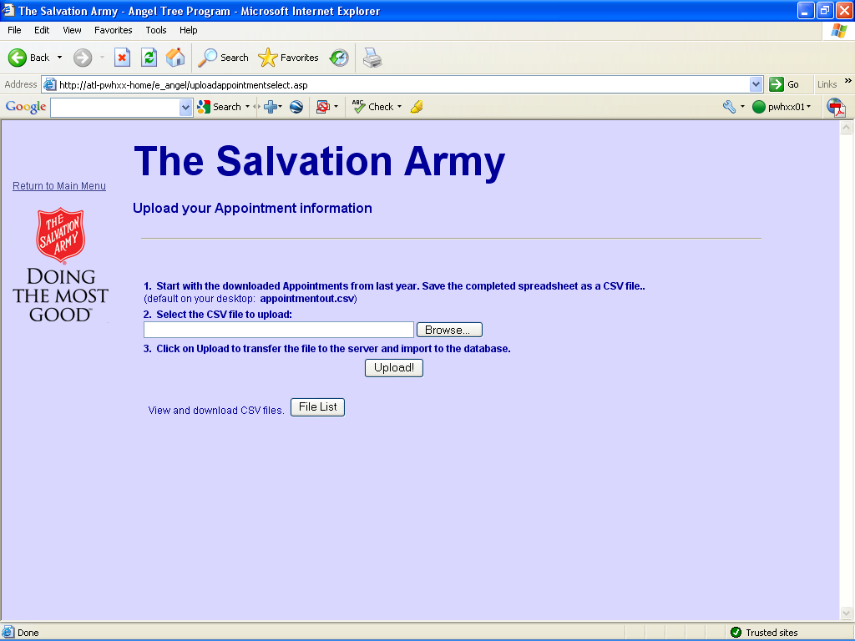
Locate and select the CSV file that contains the new zip codes and click upload

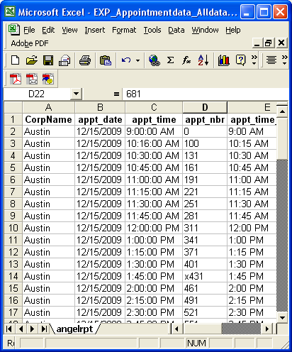
There are edits for each field in the CSV file and these will be reported on the next screen with the results:

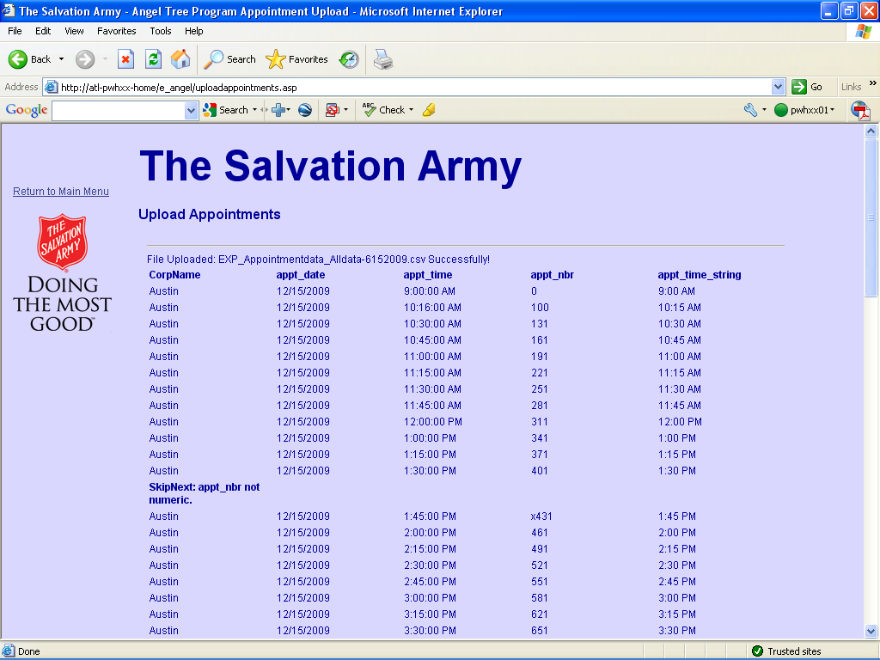
Review the results.
If you had purged appointments with the database utilities screen, you may need to delete or edit the zero and 20000 records.
Client Appointments Setup
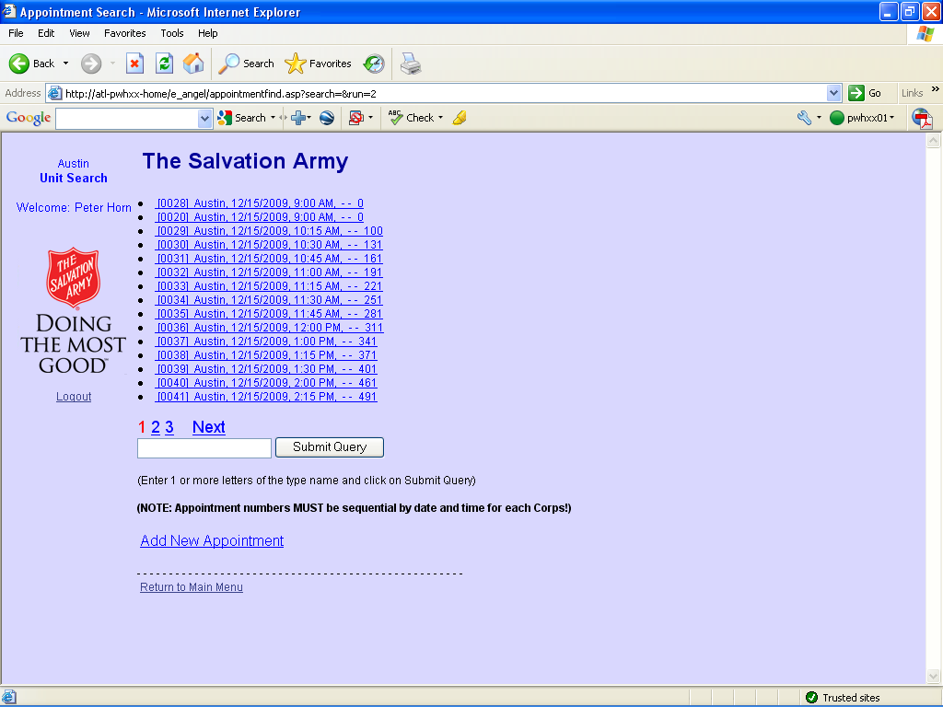
Select an appointment record or click on Add New Appointment.
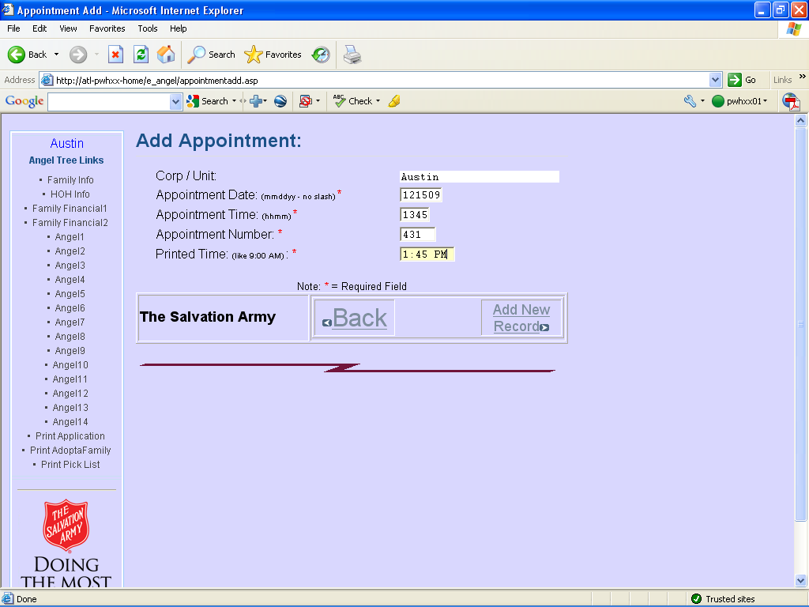

Note: Appointment Time is in 24hr/millitary time – 1:45 = 1345

2. Managing Angel Applications and donations

Add/Edit Bike and Large Box List
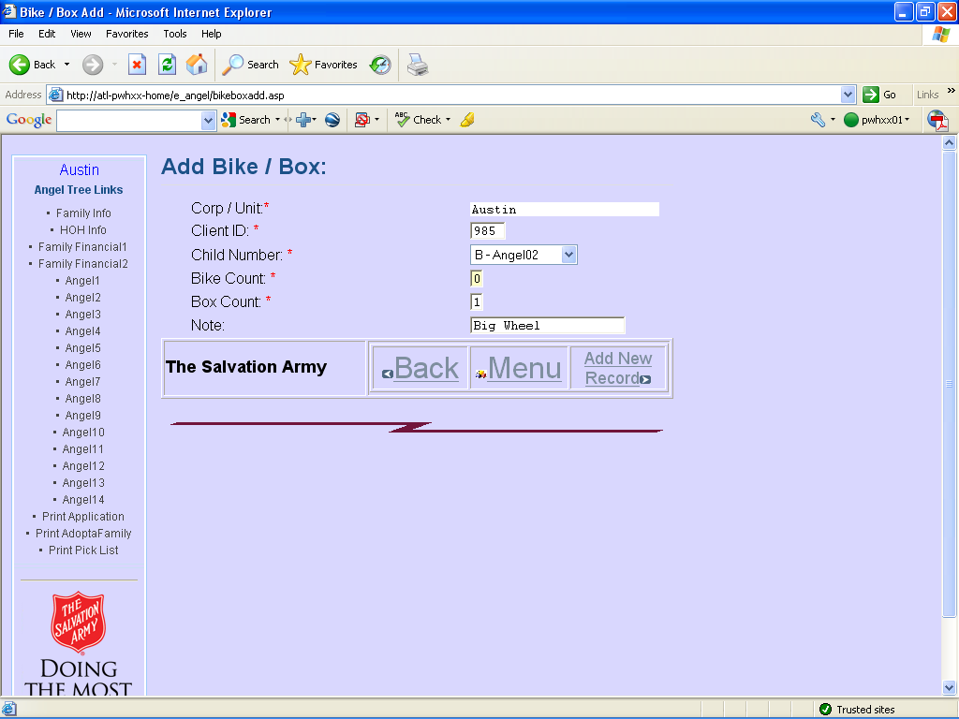

A very useful spreadsheet for managing and organizing bikes and large boxes in the warehouse for pickup day.

Change Appointment on Application
Allows you to change an auto-assigned appointment to some other time.
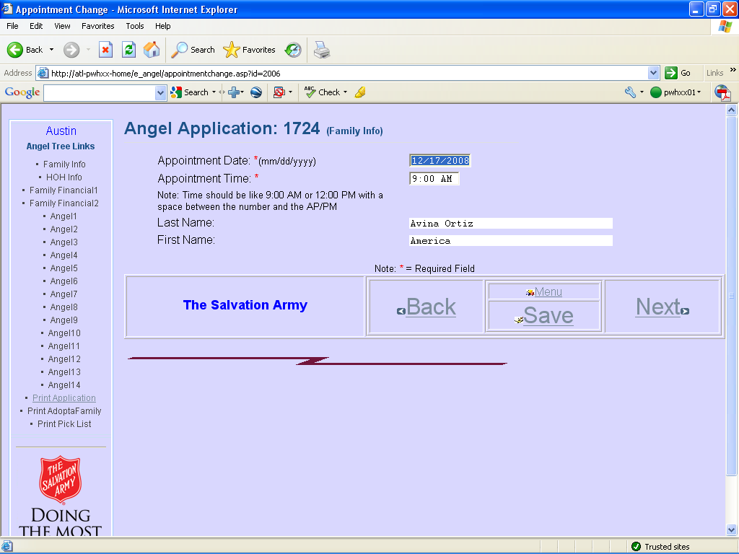
Bag Count Update
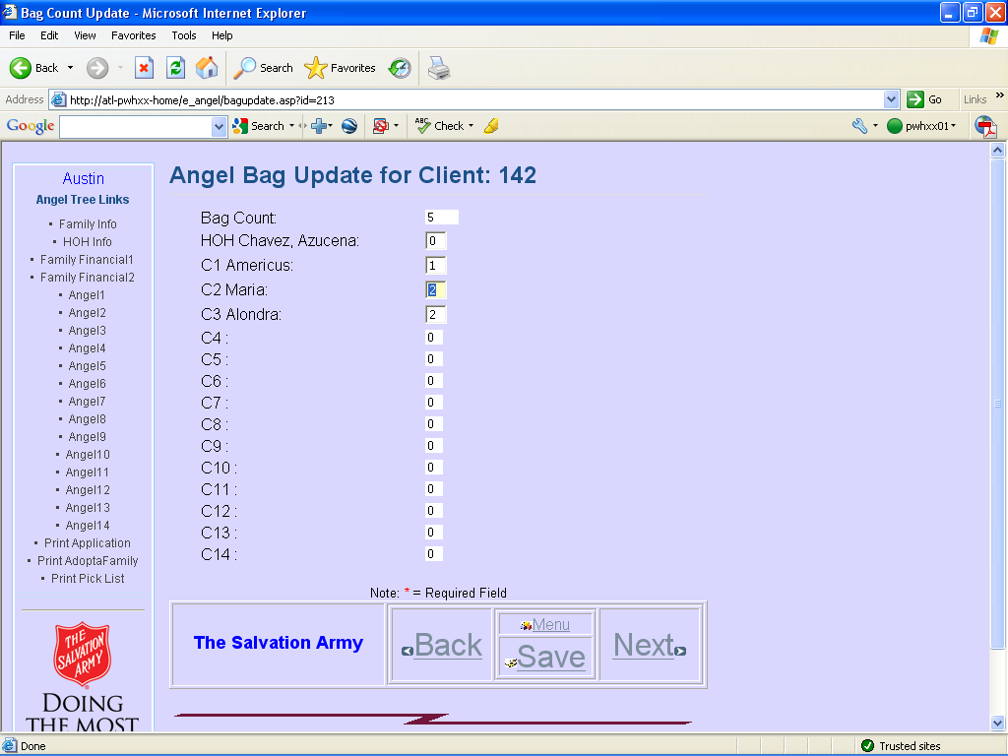

If you are not using the bar code scanner option, you can still manually count the bags in the warehouse and update the system – this will print on the picklist report.
Download Angel reporting software
Allows distributing programs (like the angel print program) or other files from the server so that users in remote locations can download the files to their PC.
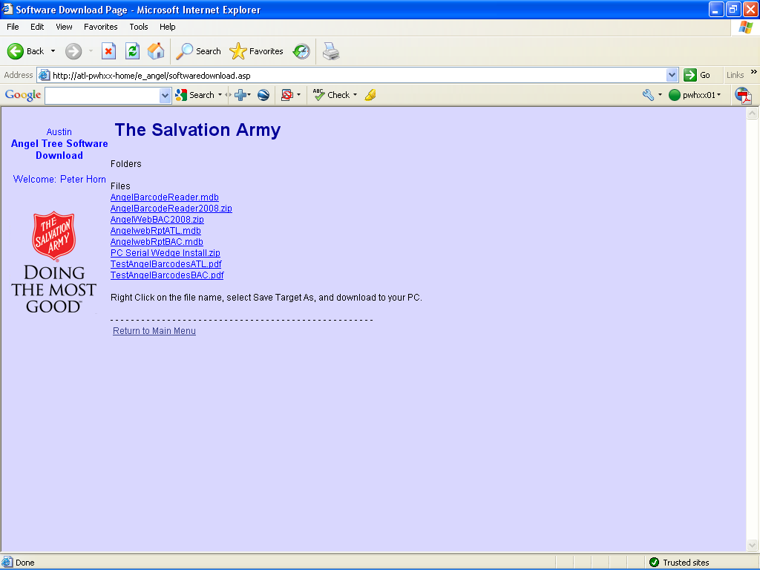

Upload BarCode file.
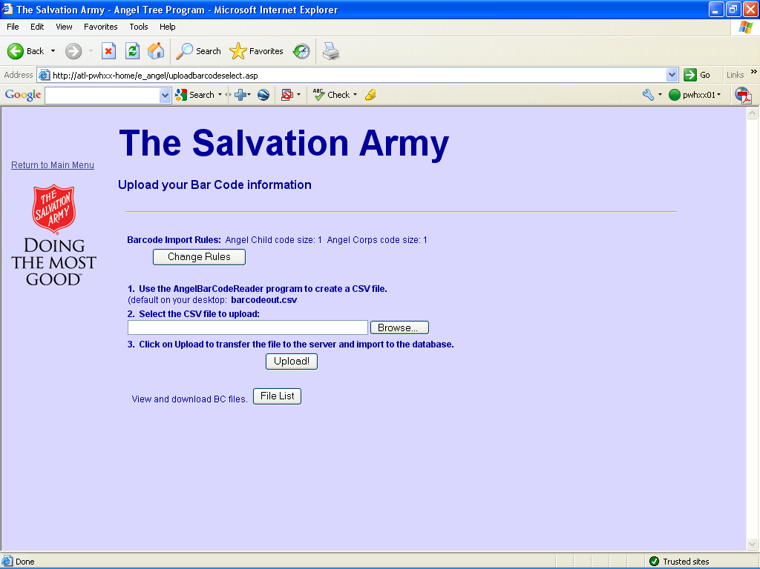
Use this screen to upload the CSV file from the BarCode Reader program This will then be loaded and matched against the Angels in the system. You can also use the Change Rules button to modify the nbr of characters for either the Corp Code or the Angel ID.

3. Reports

Angel Count
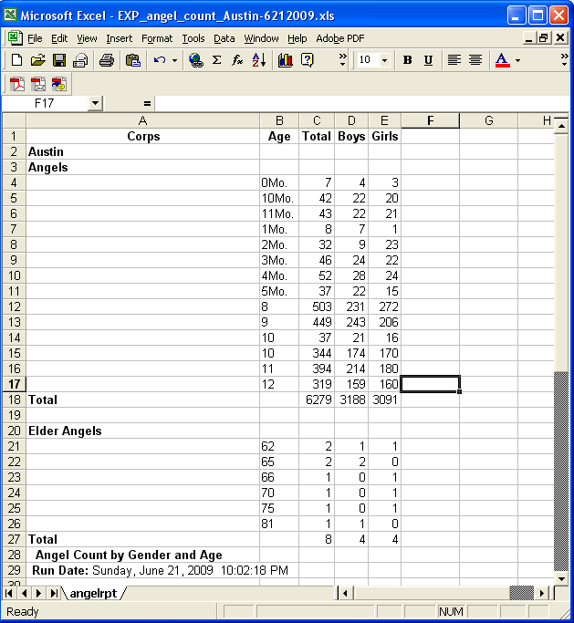
Angel Count by City
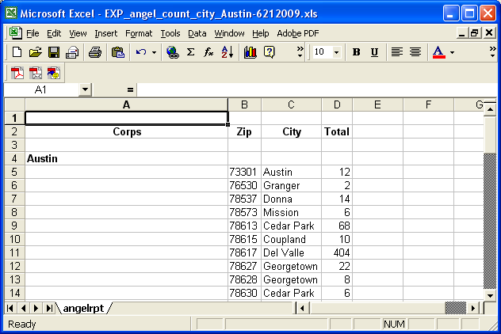
Angel Count by County
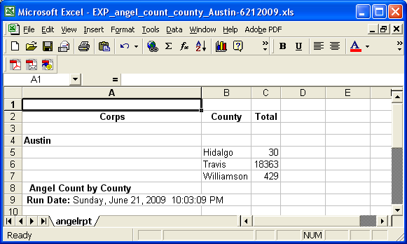
Angel Errors
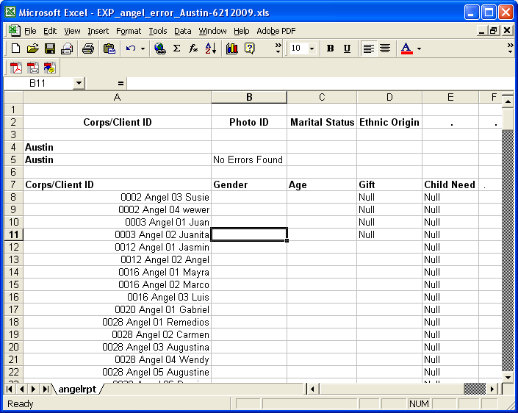
App Count by City
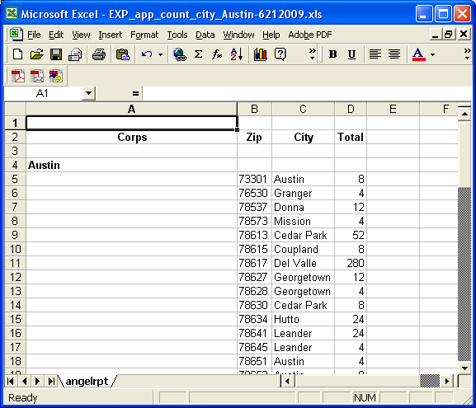
App Count by County
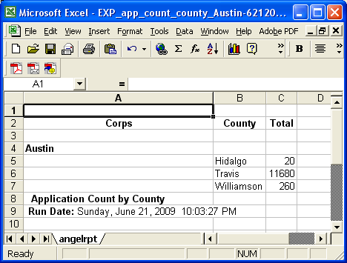
Appointment counts
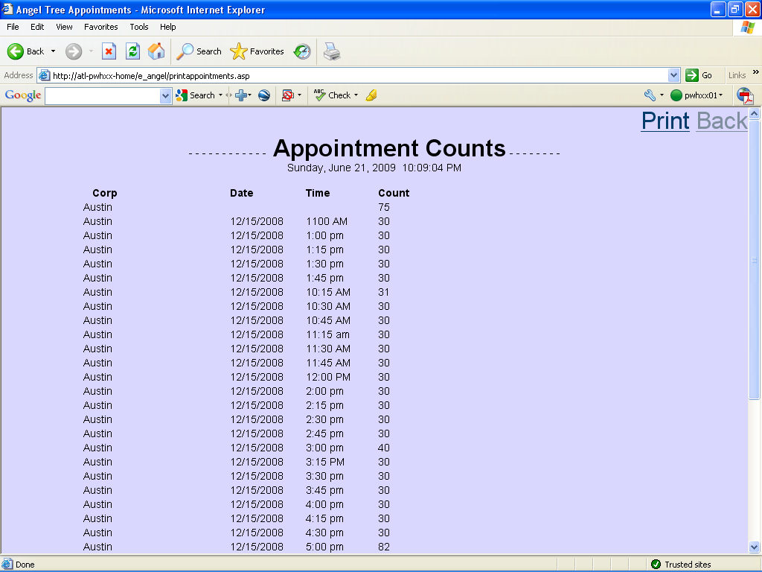

Appointment List
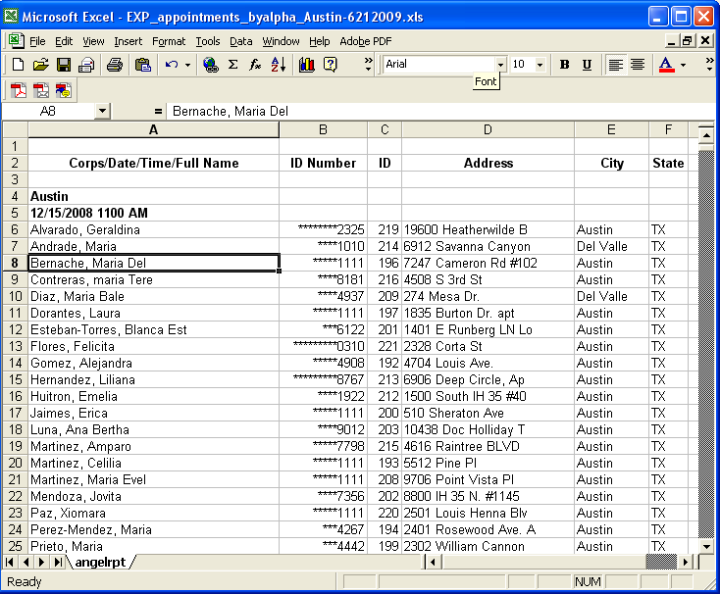
Apps and Angels count
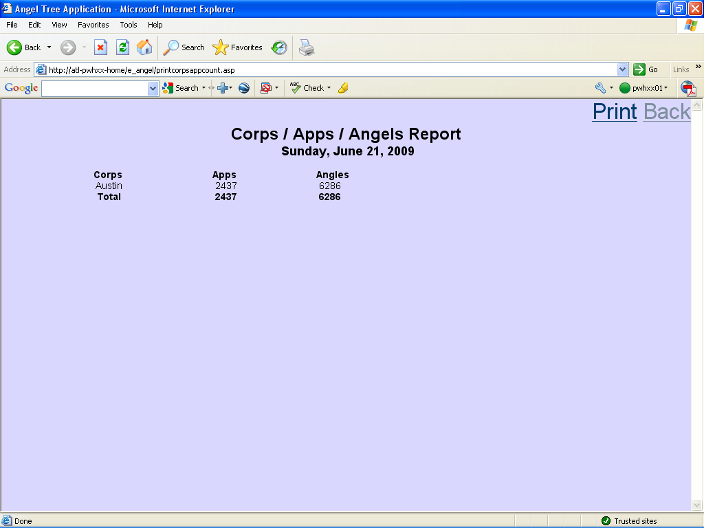
Bag Count
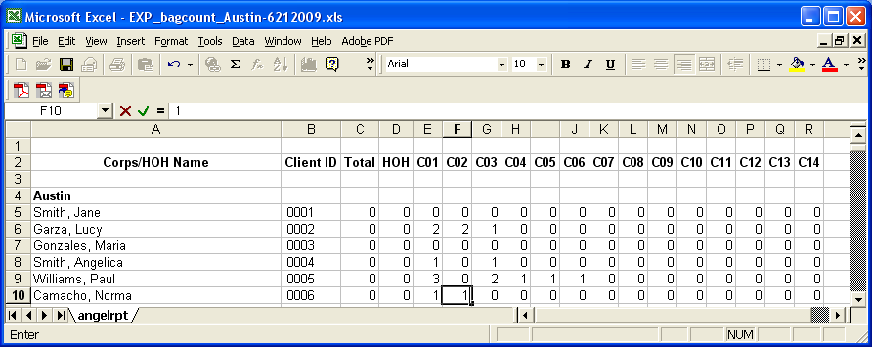
Bike and Large Box
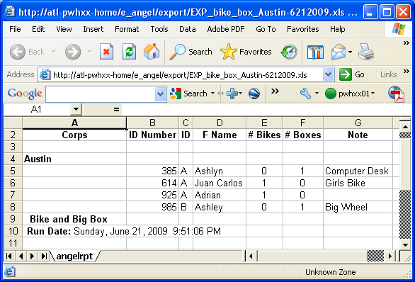
These 4 downloads may be used as input to other programs.
Download Angel Data(+/- 2 minutes)
This is the input to feed into the Angel Printing program.
Note: Once the spreadsheet file has been saved to your PC, you must open it with
Excel and do a SAVE AS to type Microsoft Excel Workbook (*.xls)
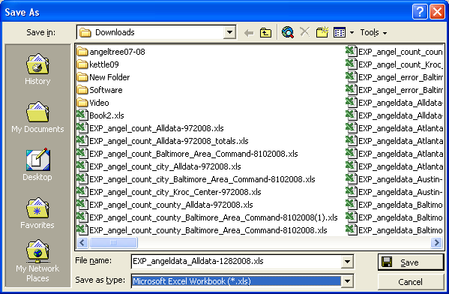
This is a limitation of a web page saving a spreadsheet – it is really an html document. We must save it once as a ‘real’ spreadsheet so that MS Access can open the file to import it.

Download Full Data(+/- 10 minutes)
This is a full backup of all of the angel data.
Download HOH Data(+/- 2 minutes)
This can be used to send reminder letters as it contains the contact name and address info.
Download Sponsor(+/- 2 minutes)
This can be shared with sponsor or other groups. Angel data has been ‘sanitized’.
HOH by Alpha
Useful report when looking for incomplete applications (no HOH name sorts to the top).

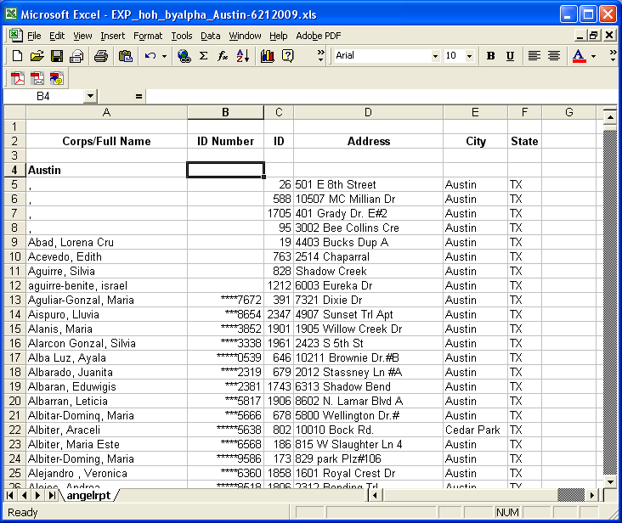
HOH by Family Size
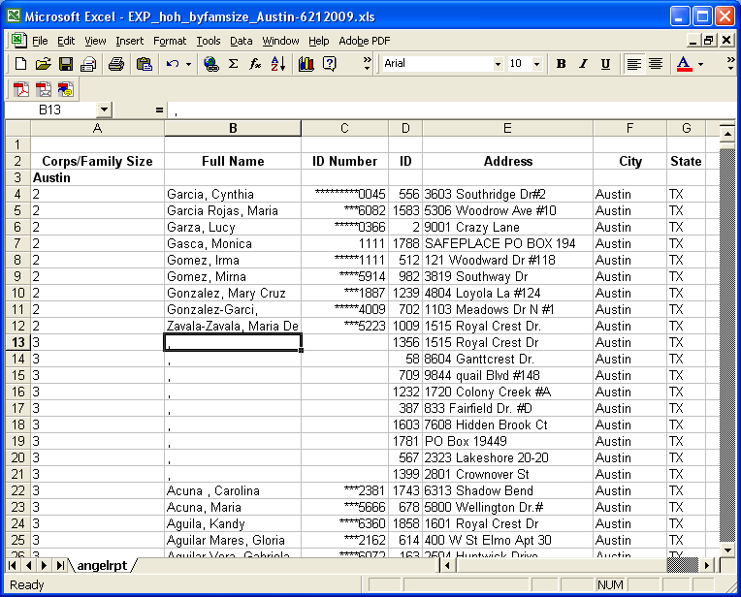

HOH by ID
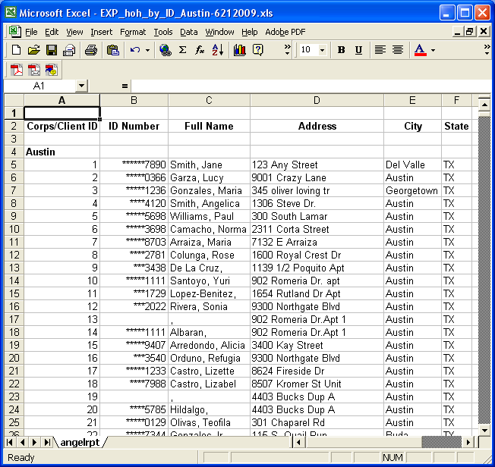
HOH by SSN
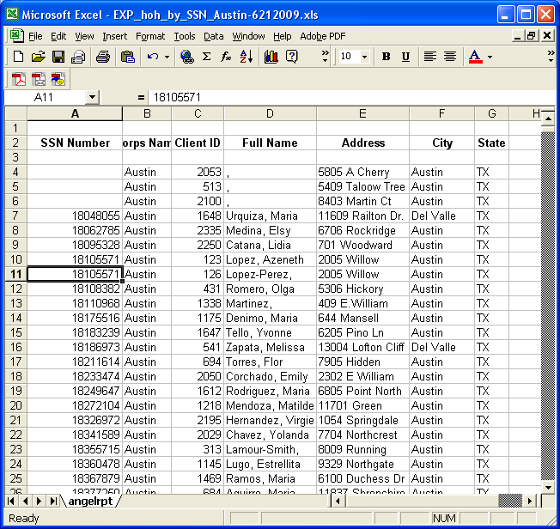
Income <>$5000
Useful report for looking for mistakes in entering financial info. This shows applications
that have a net income calc of less that -$5,000.00 or more than +$5,000.00 .

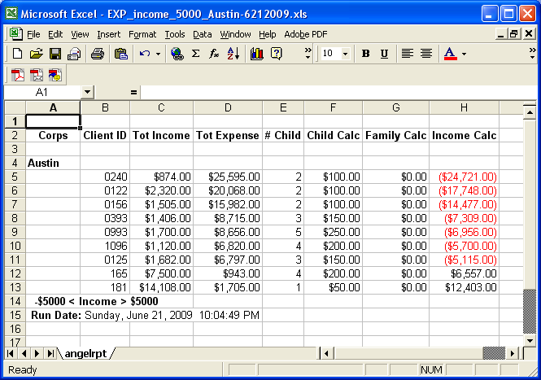
Income All
This shows all applications along with the approved / not approved status.
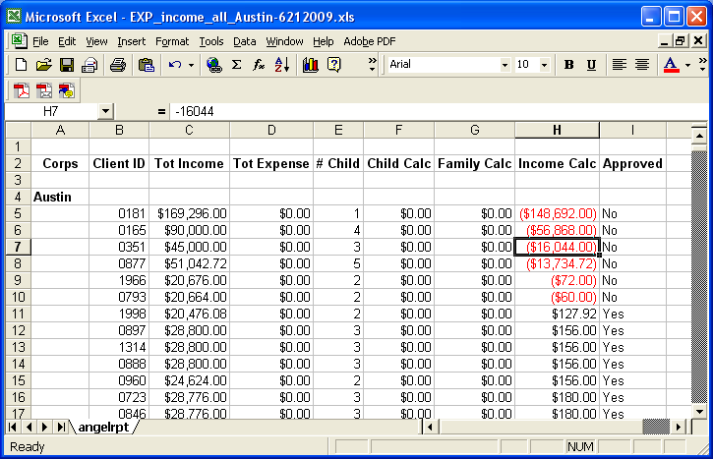
Members by ID
Lists Apps and children by ID order
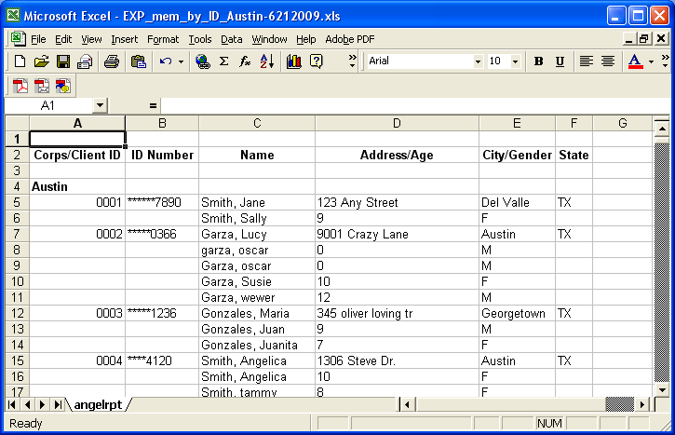
SSI Duplicates
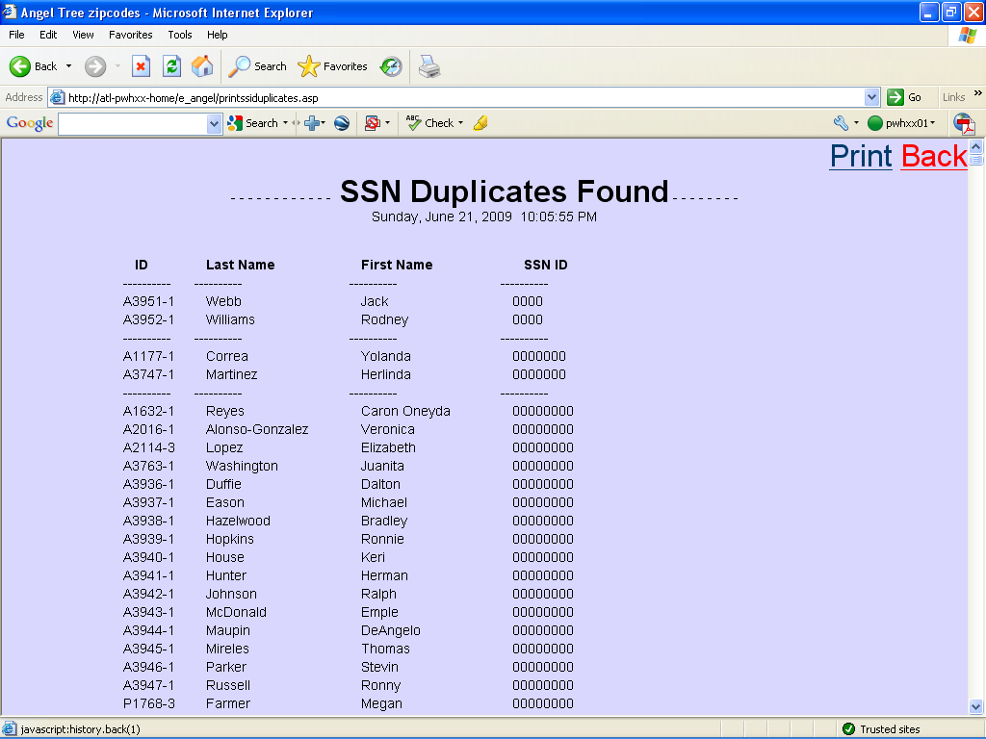

Statistics
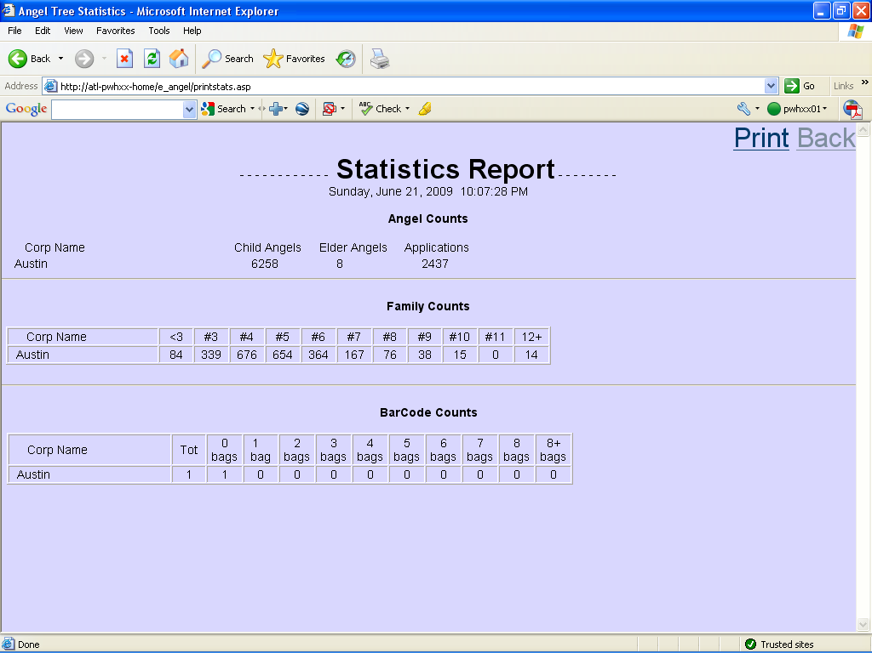
Zip code list
